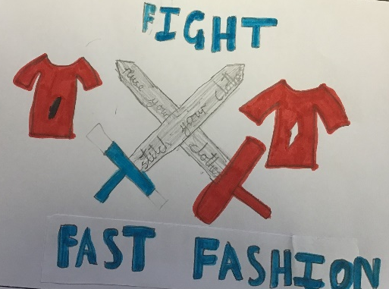
We pledge to help recycle clothing, including school uniforms which supports families and school fundraisers.

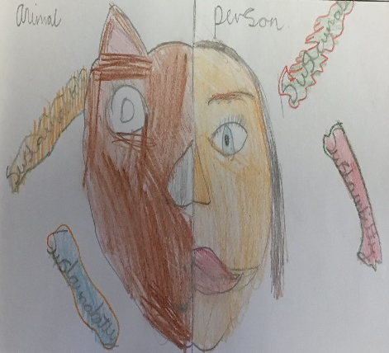
We pledge to take care of animals and their habitats in our school surroundings and community.

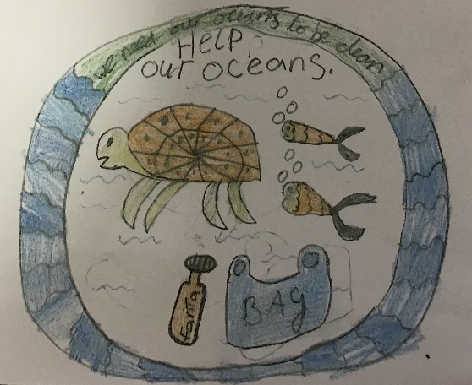
To take care of our oceans, we will raise awareness in our community and reduce the amount of single use plastic that we use in school.
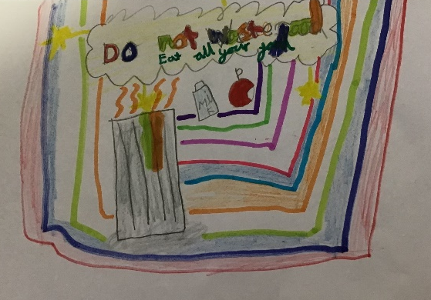
We pledge that we will try to eat everything our plates. If we can’t finish it, we will ask for a smaller portion next time.
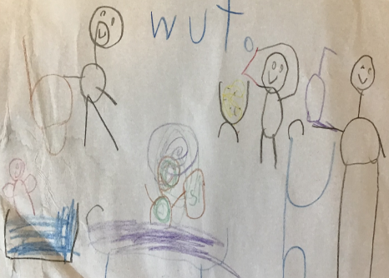
We pledge to finish our water bottles so that we don’t waste water.

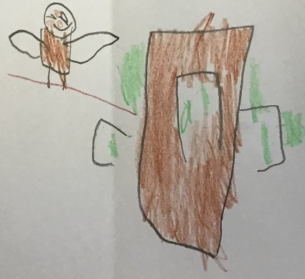
Everyone will protect the animals and respect the woodlands.

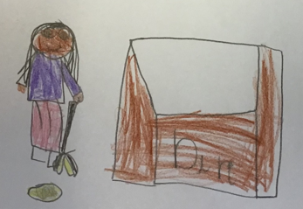
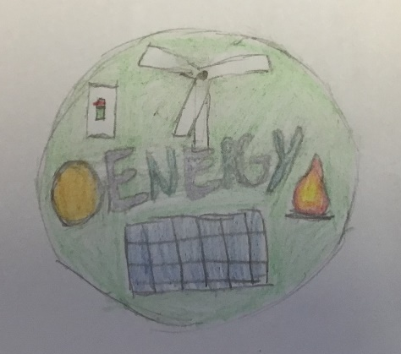
We pledge to keep the community nice and clean.
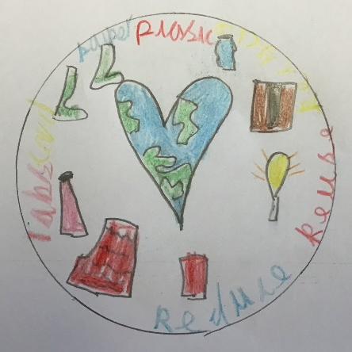

Our pledge is to reduce waste, reuse when we can and recycle when we can.

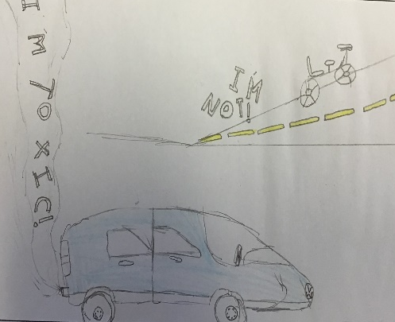
We pledge to cut pollution by walking and using our bikes when travelling to and from school.
We pledge to turn off plugs and lights when we aren’t using them to help save energy from non-renewable sources.

Logo competition!

Ash- Robin
Elm- Riya
Birch- Samir
Almond- Alice
Cedar- Ava-Mae
Hawthorn- Millie
Elder- Layla
Beech- Jessie
Chestnut- Kody
Oak- Damian

Our whole school celebrated Sustainability Day, with each class exploring issues they felt were important to discuss. In the afternoon, children took part in a logo competition, learned about current environmental challenges, engaged in debates, and created pledges to help make our world a better place for future generations. These pledges were then combined to form our whole-school pledge, shown below.

