Progression towards a Written Method for Addition

In developing a written method for addition, it is important that children understand the concept of addition, in that it is:
- Combining two or more groups to give a total or sum
- Increasing an amount

They also need to understand and work with certain principles, i.e. that it is:
- the inverse of subtraction
- commutative i.e. 5 + 3 = 3 + 5
- associative i.e. 5 + 3 + 7 = 5 + (3 + 7)

The fact that it is commutative and associative means that calculations can be rearranged, e.g.
4 + 13 = 17 is the same as 13 + 4 = 17.

yr
Early Learning Goal:
Subitise up to 5. Deep understanding numbers to 10 including the composition of each number. Automatically recall bonds up to 5 and some number bonds to 10 including double facts. Verbally count beyond 20 recognising the pattern of the counting system. Compare quantities up to in different contexts recognising when one quantity is greater than, less than or the same as the other quantity. Explore and represent patterns in numbers up 10 including evens and odd, double facts and how quantities can be distributed equally.

Children are encouraged to develop a mental picture of the number system in their heads to use for calculation. They should experience practical calculation opportunities using a wide variety of practical equipment, including small world play, role play, counters, cubes etc.

Counting all method
Children will begin to develop their ability to add by using practical equipment to count out the correct amount for each number in the calculation and then combine them to find the total. For example, when calculating 4 + 2, they are encouraged to count out four counters and count out two counters.

To find how many altogether, touch and drag them into a line one at a time whilst counting.

6
5
4
3
2
1

By touch counting and dragging in this way, it allows children to keep track of what they have already counted to ensure they don’t count the same item twice.
Counting on method
To support children in moving from a counting all strategy to one involving counting on, children should still have two groups of objects but one should be covered so that it cannot be counted. For example, when calculating 4 + 2, count out the two groups of counters as before.

then cover up the larger group with a cloth.

4

For most children, it is beneficial to place the digit card on top of the cloth to remind the children of the number of counters underneath. They can then start their count at 4, and touch count 5 and 6 in the same way as before, rather than having to count all of the counters separately as before.
Those who are ready may record their own calculations.

Y1
End of Year Objective:
Add one-digit and two-digit numbers to 20, including zero (using concrete objects and pictorial representations).

Children will continue to use practical equipment, combining groups of objects to find the total by counting all or counting on.

The emphasis in Year 1 is to develop mental methods, e.g. number bonds, counting on, making ten.

Y2
End of Year Objective:
Add numbers using concrete objects, pictorial representations, and mentally, including: a two-digit number and ones; a two-digit number and tens; two two-digit numbers; three one-digit numbers.



Children will use the Base 10 equipment to support their calculations. For example, to calculate 32 + 21, they can make the individual amounts, counting the tens first and then count on the units.

53

When the units total more than 10, children should be encouraged to rename 10 units/ones for 1 ten. This is the start of children understanding ‘carrying’ in vertical addition. For example, when calculating
35 + 27, they can represent the amounts using Base 10 as shown:

Then, identifying the fact that there are enough units/ones to rename for a ten, they can carry out this renaming process:


To leave:

Children can also record the calculations using their own drawings of the Base 10 equipment (as lines for the 10 rods and dots for the unit blocks).
e.g. 34 + 23 =

With renaming:
renamed 10
e.g. 28 + 36 =

will become

so 28 + 36 = 64

This method can also be used with adding three digit numbers, e.g. 122 + 217 using a square as the representation of 100.
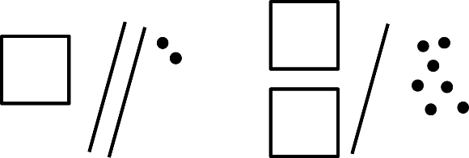

Y3
End of Year Objective:
Add numbers with up to three digits, using formal written method of columnar addition.*

*Although the objective suggests that children should be using formal written methods, the National Curriculum document states “The programmes of study for mathematics are set out year-by-year for key stages 1 and 2. Schools are, however, only required to teach the relevant programme of study by the end of the key stage. Within each key stage, schools therefore have the flexibility to introduce content earlier or later than set out in the programme of study.” p4

It is more beneficial for children’s understanding to go through the expanded methods of calculation as steps of development towards a formal written method.

Children will build on their knowledge of using Base 10 equipment from Y2 and continue to use the idea of renaming.

Children should add the least significant digits first (i.e. start with the units/ones), and in an identical method to that from year 2, should identify whether there are greater than ten units which can be renamed for one ten.

They can use a place value grid to begin to set the calculation out vertically and to support their knowledge of renaming between columns (as in Step 1 in the diagram below).
e.g. 65 + 27

Step 1 Step 2
T U
T U

Renamed ten

Remaining units

Children would rename ten units/ones for a ten, placing the renamed ten above the calculation. Any remaining units/ones that cannot be renamed for a ten move into the equals sign as they are the units/ones part of the answer (as in the diagram in Step 2 above).

If there are any tens that can be renamed for a hundred, this can be done next. If not, the tens move into the equals sign as they are the tens part of the answer (as in the diagram in Step 3 below).

Step 3 Written method
T U
Step 1 Step 2 Step 3
 | T  1 | U
 | 6 | 5
+ | 2 | 7
 | 9 | 2

 | T  1 | U
 | 6 | 5
+ | 2 | 7
 |  | 2

 | T | U
 | 6 | 5
+ | 2 | 7

Children should utilise this practical method to link their understanding of exchange to how the column method is set out. Teachers should model the written method alongside this practical method initially.
This should progress to children utilising the written and practical methods alongside each other and finally, and when they are ready, to children utilising just the written method.

By the end of year 3, children should also extend this method for three digit numbers.

Y4
End of Year Objective:
Add numbers with up to 4 digits using the formal written method of columnar addition where appropriate.

Children will move to year 4 using whichever method they were using as they transitioned from year 3. They will be using place value counters instead of base 10, where appropriate.

Step 1
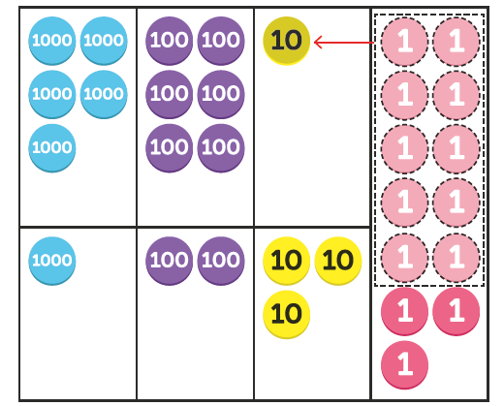
 | Th | H | T  1 | U
 | 5 | 6 | 0 | 8
+ | 1 | 2 | 3 | 5
 |  |  |  | 3

Step 2
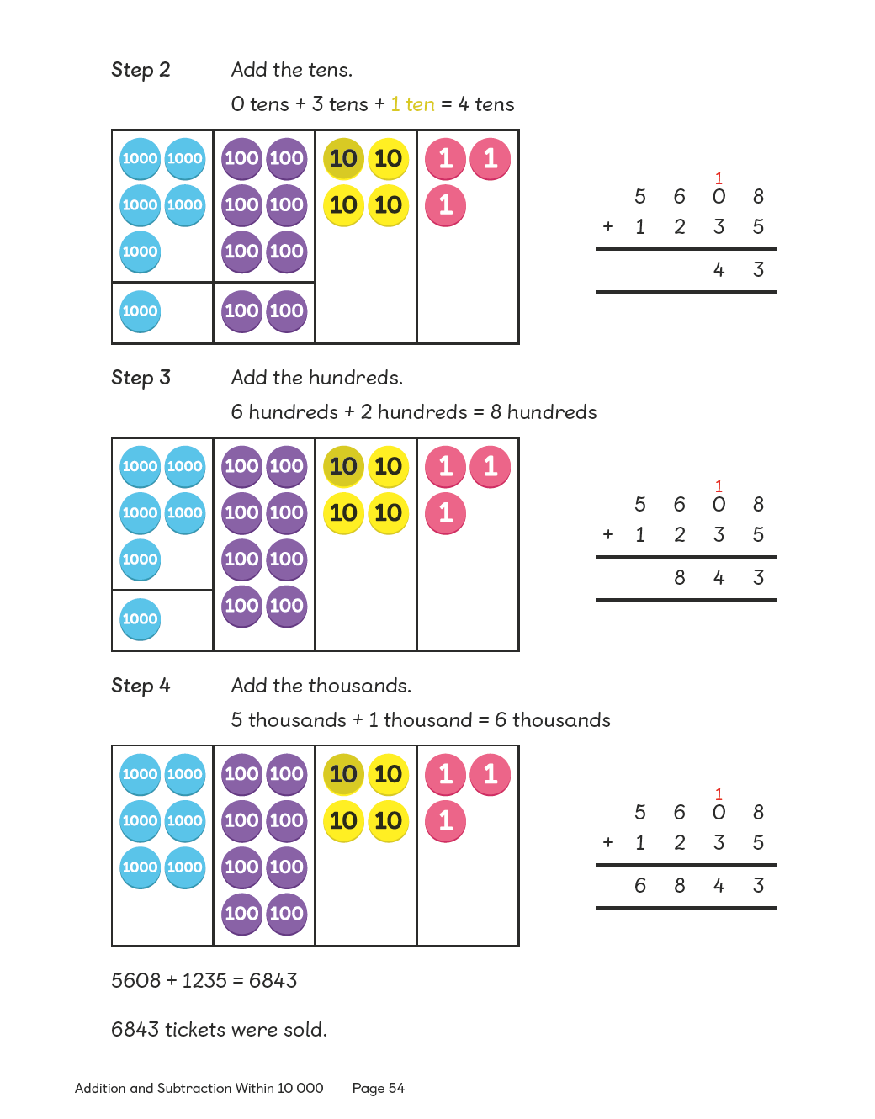
 | Th | H | T  1 | U
 | 5 | 6 | 0 | 8
+ | 1 | 2 | 3 | 5
 |  |  | 4 | 3

Step 3

 | Th | H | T  1 | U
 | 5 | 6 | 0 | 8
+ | 1 | 2 | 3 | 5
 |  | 8 | 4 | 3

Step 4
 | Th | H | T | U
 |  |  | 1
 | 5 | 6 | 0 | 8
+ | 1 | 2 | 3 | 5
 | 6 | 8 | 4 | 3

By the end of year 4, children should be using the written method confidently and with understanding. They will also be adding several numbers with different numbers of digits, understanding the place value.

Y5
End of Year Objective:
Add whole numbers with more than 4 digits including formal written methods (columnar addition).

Children should continue to use the compact method to solve calculations such as:

 | 3 | 1  3 | 1  6 | 4
+ |  | 2 | 4 | 7
 | 3 | 6 | 1 | 1

 | 3 | 1  1 | 1  2 | 1
 |  |  | 3 | 7
+ |  | 1 | 4 | 8
 | 3 | 3 | 0 | 6

 | 3 | . | 1  5 | 6
+ | 2 | . | 4 | 7
 | 6 | . | 0 | 3

They will also be adding:

- several numbers with different numbers of digits, understanding the place value;
- decimals with up to two decimal places (with each number having the same number of decimal places), knowing that the decimal points line up under one another.
- amounts of money and measures, including those where they have to initially convert from one unit to another

Y6
End of Year Objective:
Add whole numbers and decimals using formal written methods (columnar addition).

Children should extend the compact method and use it to add whole numbers and decimals with any number of digits.
 | 1 | 1 | 2 | 1  4 | 2
 |  | 6 | 4 | 3 | 2
 |  |  | 7 | 8 | 6
 |  |  |  |  | 3
+ |  | 4 | 6 | 8 | 1
 | 1 | 1 | 9 | 4 | 4

When adding decimals with different numbers of decimal places, children should be taught and encouraged to make them the same through identification that 2 tenths is the same as 20 hundredths, therefore, 0.2 is the same value as 0.20.
 | 4 | 0 | 1  1 | . | 2 | 0
 |  | 2 | 6 | . | 8 | 5
+ |  |  | 0 | . | 7 | 1
 | 4 | 2 | 8 | . | 7 | 6

They will also be adding:

- several numbers with different numbers of digits, understanding the place value;
- decimals with up to two decimal places (with mixed numbers of decimal places), knowing that the decimal points line up under one another.
- amounts of money and measures, including those where they have to initially convert from one unit to another.

