Progression Towards a Written Method for Subtraction

In developing a written method for subtraction, it is important that children understand the concept of subtraction, in that it is:
- Removal of an amount from a larger group (take away)
- Comparison of two amounts (difference)

They also need to understand and work with certain principles, i.e. that it is:
- the inverse of addition
- not commutative i.e. 5 - 3 is not the same as 3 - 5
- not associative i.e. 10 - 3 - 2 is not the same as 10 - (3 - 2)

yr
Early Learning Goal:
Subitise up to 5. Deep understanding numbers to 10 including the composition of each number. Automatically recall bonds up to 5 and some number bonds to 10 including double facts. Verbally count beyond 20 recognising the pattern of the counting system. Compare quantities up to in different contexts recognising when one quantity is greater than, less than or the same as the other quantity. Explore and represent patterns in numbers up 10 including evens and odd, double facts and how quantities can be distributed equally.

Children are encouraged to develop a mental picture of the number system in their heads to use for calculation. They should experience practical calculation opportunities using a wide variety of practical equipment, including small world play, role play, counters, cubes etc.

Taking away
Children will begin to develop their ability to subtract by using practical equipment to count out the first number and then remove or take away the second number to find the solution by counting how many are left e.g. 9 – 4.

For illustration purposes, the amount being taken away are show crossed out. Children would be encouraged to physically remove these using touch counting.

2
3

1
4

By touch counting and dragging in this way, it allows children to keep track of how many they are removing so they don’t have to keep recounting. They will then touch count the amount that are left to find the answer.
Those who are ready may record their own calculations.

Y1
End of Year Objective:
Subtract one-digit and two-digit numbers to 20, including zero (using concrete objects and pictorial representations).

Children will continue to use practical equipment and taking away strategies.

The emphasis in Year 1 is to develop mental methods, e.g. number bonds, counting back, partitioning.

Y2
End of Year Objective:
Subtract numbers using concrete objects, pictorial representations, and mentally, including: a two-digit number and ones; a two-digit number and tens; two two-digit numbers.

Children will begin to use the Base 10 equipment to support their calculations, still using a take away, or removal, method. They need to understand that the number being subtracted does not appear as an amount on its own, but rather as part of the larger amount. For example, to calculate 54 - 23, children would count out 54 using the Base 10 equipment (5 tens and 4 units/ones). They need to consider whether there are enough units/ones to remove 3, in this case there are, so they would remove 3 units and then two tens, counting up the answer of 3 tens and 1 unit to give 31.




so 54 – 23 = 31
which leaves

Children can also record the calculations using their own drawings of the Base 10 equipment (as lines for the 10 rods and dots for the unit blocks), e.g. to calculate 39 – 17 children would draw 39 as 3 tens (lines) and 4 units (dots) and would cross out 7 units and then one ten, counting up the answer of 2 tens and 2 units to give 22.

Circling the tens and units that remain will help children to identify how many remain.

When the amount of units to be subtracted is greater than the units in the original number, a renaming method is required. This relies on children’s understanding of ten units being an equivalent amount to one ten. To calculate 53 – 26, by using practical equipment, they would count out 53 using the tens and units, as in Step 1. They need to consider whether there are enough units/ones to remove 6. In this case there are not so they need to rename a ten into ten ones to make sure that there are enough, as in step 2.

Step 1 Step 2

becomes

The children can now see the 53 represented as 40 and 13, still the same total, but partitioned in a different way, as in step 3 and can go on to take away the 26 from the calculation to leave 27 remaining, as in Step 4.

Step 3 Step 4

When recording their own drawings, when calculating 37 – 19, children would cross out a ten and rename this for ten units.

Step 1 Step 2 Step 3

Circling the tens and units that remain will help children to identify how many remain.

Y3
End of Year Objective:
Subtract numbers with up to three digits, using formal written method of columnar subtraction.*

*Although the objective suggests that children should be using formal written methods, the National Curriculum document states “The programmes of study for mathematics are set out year-by-year for key stages 1 and 2. Schools are, however, only required to teach the relevant programme of study by the end of the key stage. Within each key stage, schools therefore have the flexibility to introduce content earlier or later than set out in the programme of study.” p4

It is more beneficial for children’s understanding to go through the expanded methods of calculation as steps of development towards a formal written method.

Children will build on their knowledge of using Base 10 equipment from year 2 and continue to use the idea of renaming. This process can be demonstrated using arrow cards to show the partitioning and Base 10 materials to represent the first number, removing the units and tens as appropriate (as with the more informal method in year 2).

Step 1 Step 2
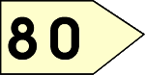
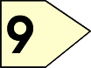
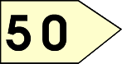
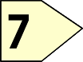

Step 3
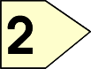
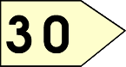

Emphasise that the second (bottom) number is being subtracted from the first (top) number rather than the lesser number from the greater.

This can be recorded by the children as:
 | 80 |  | 9
- | 50 |  | 7
 | 30 |  | 2 | = | 32

From this the children will begin to solve problems which involve renaming. Children need to consider whether there are enough units/ones to remove 6. In this case there are not (Step 1) so they need to rename a ten into ten ones to make sure that there are enough, as they have been doing in the method for year 2 (Step 2). They should be able to see that the number is just partitioned in a different way, but the amount remains the same (71 = 70 + 1 = 60 + 11).

Step 1 Step 2
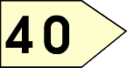
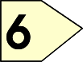
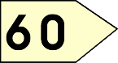
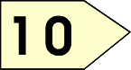
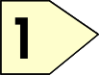
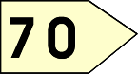

Step 3 Step 4
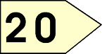
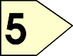

This can be recorded by the children as:

 | 60
 | 70 |  | ¹1
- | 40 |  | 6
 | 20 |  | 5 | = | 25

When children are ready, this leads on to the compact method of decomposition:
 |  |  | ₂
 | 8 | 3 |  |  | ¹1
- |  | 2 |  |  | 6
 | 8 | 0 |  |  | 5

Y4
End of Year Objective:
Subtract numbers with up to 4 digits using the formal written method of columnar subtraction where appropriate.

Children will move to year 4 using whichever method they were using as they transitioned from year 3.

Step 1
 |  |  |  |  | ₇
 | 5 |  | 2 | 8 |  | ¹0
- | 3 |  | 1 | 6 |  | 9

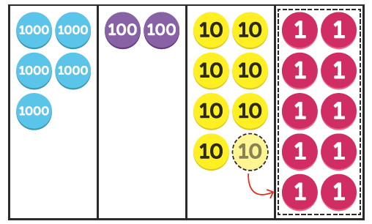

Step 2
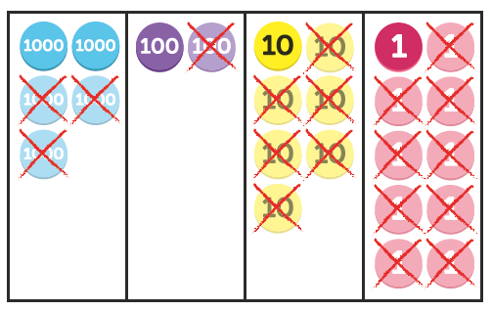
 |  |  |  |  | ₇
 | 5 |  | 2 | 8 |  | ¹0
- | 3 |  | 1 | 6 |  | 9
 | 2 |  | 1 | 1 |  | 1

By the end of year 4, children should be using the written method confidently and with understanding. They will also be subtracting numbers with different numbers of digits, understanding the place value.

Y5
End of Year Objective:
Subtract whole numbers with more than 4 digits including formal written methods (columnar subtraction).

Children should continue to use the decomposition method to solve calculations such as:

 | ₆ |  | ₆
 | 7 | ¹0 | 7 | ¹2
- | 3 | 2 | 2 | 6
 | 3 | 8 | 4 | 6

 | ₂ |  | ₁₃
 | 3 | . | 4 | ¹2
- | 1 | . | 7 | 6
 | 1 | . | 6 | 6

They will also be subtracting:

- numbers with different numbers of digits, understanding the place value;
- decimals with up to two decimal places (with each number having the same number of decimal places), knowing that the decimal points line up under one another.
- amounts of money and measures, including those where they have to initially convert from one unit to another

Y6
End of Year Objective:
Subtract whole numbers and decimals using formal written methods (columnar subtraction).

Children should extend the decomposition method and use it to subtract whole numbers and decimals with any number of digits.
 |  | ₅ | ₁₃
 |  | 6 | 4 | ¹3 | 2
- |  | 4 | 6 | 8 | 1
 |  | 1 | 7 | 5 | 1

 | ₃ |  | ₆ |  | ₁₁
 | 4 | ¹1 | 7 | . | 2 | ¹0
- |  | 3 | 4 | . | 7 | 1
 | 3 | 8 | 2 | . | 4 | 9

When subtracting decimals with different numbers of decimal places, children should be taught and encouraged to make them the same through identification that 2 tenths is the same as 20 hundredths, therefore, 0.2 is the same value as 0.20.

They will also be subtracting:

- numbers with different numbers of digits, understanding the place value;
- decimals with up to two decimal places (with mixed numbers of decimal places), knowing that the decimal points line up under one another.
- amounts of money and measures, including those where they have to initially convert from one unit to another.

