Progression towards a Written Method for Division

In developing a written method for division, it is important that children understand the concept of division, in that it is:
- repeated subtraction

They also need to understand and work with certain principles, i.e. that it is:
- the inverse of multiplication
- not commutative i.e. 15 ÷3 is not the same as 3 ÷ 15
- not associative i.e. 30 ÷ (5 ÷ 2) is not the same as (30 ÷ 5) ÷ 2

YR
Early Learning Goal:
Subitise up to 5. Deep understanding numbers to 10 including the composition of each number. Automatically recall bonds up to 5 and some number bonds to 10 including double facts. Verbally count beyond 20 recognising the pattern of the counting system. Compare quantities up to in different contexts recognising when one quantity is greater than, less than or the same as the other quantity. Explore and represent patterns in numbers up 10 including evens and odd, double facts and how quantities can be distributed equally.

Children are encouraged to develop a mental picture of the number system in their heads to use for calculation. They should experience practical calculation opportunities using a wide variety of equipment, including small world play, role play, counters, cubes etc.

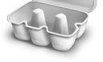
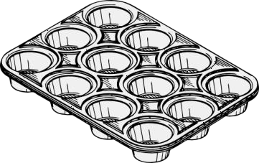
Children may also investigate sharing items or putting items into groups using items such as egg boxes, ice cube trays and baking tins which are arrays.
They may develop ways of recording calculations using pictures, etc.

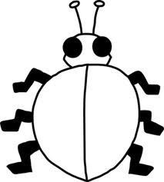
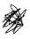
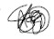
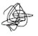
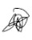
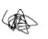
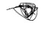
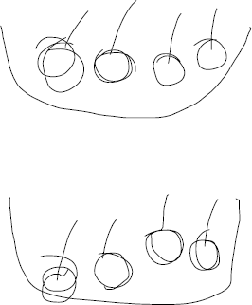
A child’s jotting showing halving six spots between two sides of a ladybird.

A child’s jotting showing how they shared the apples at snack time between two groups.

Y1
End of Year Objective:
Solve one-step problems involving division by calculating the answer using concrete objects, pictorial representations and arrays with the support of the teacher.
In year one, children will continue to solve division problems using practical equipment and jottings. They should use the equipment to understand division in 2 ways:

To group equally, answering questions such as 'If there are 8 cans, how many boxes of 2 can you make?”

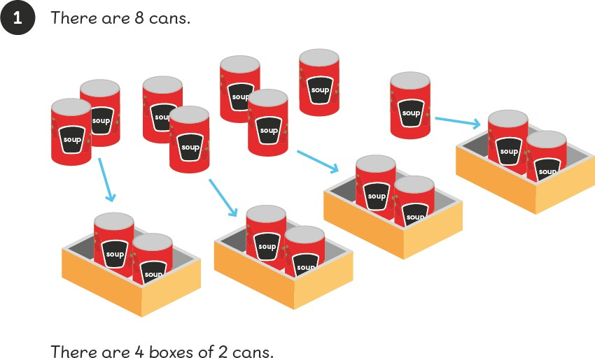

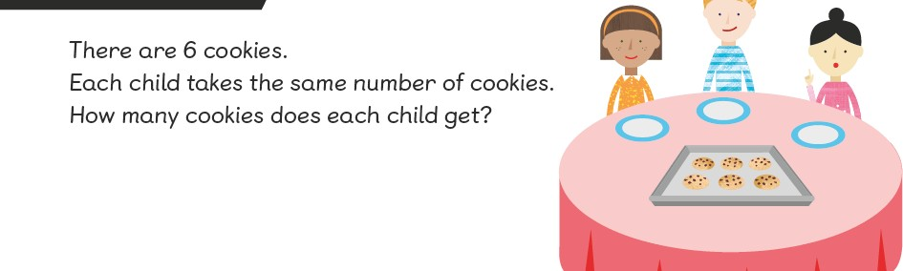
And sharing equally, answering questions such as “If we share these six apples between the three of you, how many will you each have? How do you know?’ They may solve these types of question by using a 'one for you, one for me' strategy until all of the objects have been given out.
Y2
End of Year Objective:
Calculate mathematical statements for division within the multiplication tables and write them using the division (÷) and equals (=) signs.
Children will continue their work from Year 1 to utilise practical equipment to represent division calculations as both grouping (repeated subtraction) and sharing.





When groups, they can use jottings to support their calculation, e.g. 12 ÷ 3 =

Children need to understand that this calculation reads as 'How many groups of 3 are there in 12?' The link between sharing and grouping can be modelled in the following way:
To solve the problem ‘If six football stickers are shared between two people, how many do they each get?’

Place the football stickers in a bag or box and ask the children how many stickers would need to be taken out of the box to give each person one sticker each (i.e. 2) and exemplify this by putting the cards in groups of 2 until all cards have been removed from the bag.

One sticker for each person (1 altogether)
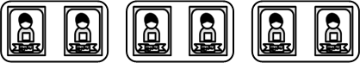
Another sticker for each person (2 altogether)
Another sticker for each person (3 altogether)

1 each 2 each 3 each
Y3
End of Year Objective:
Write and calculate mathematical statements for division using the multiplication tables that they know, including for two-digit numbers divided by one-digit numbers, progressing to formal written methods.*

*Although the objective suggests that children should be using formal written methods, the National Curriculum document states “The programmes of study for mathematics are set out year-by-year for key stages 1 and 2. Schools are, however, only required to teach the relevant programme of study by the end of the key stage.
Within each key stage, schools therefore have the flexibility to introduce content earlier or later than set out in the programme of study.” p4

Initially, children will continue to use division by grouping and sharing, where appropriate linked to the multiplication tables that they know (2, 3, 4, 5, 8 and 10).

Children will then begin to develop to dividing the tens and the units separately, using practical equipment to support, e.g.
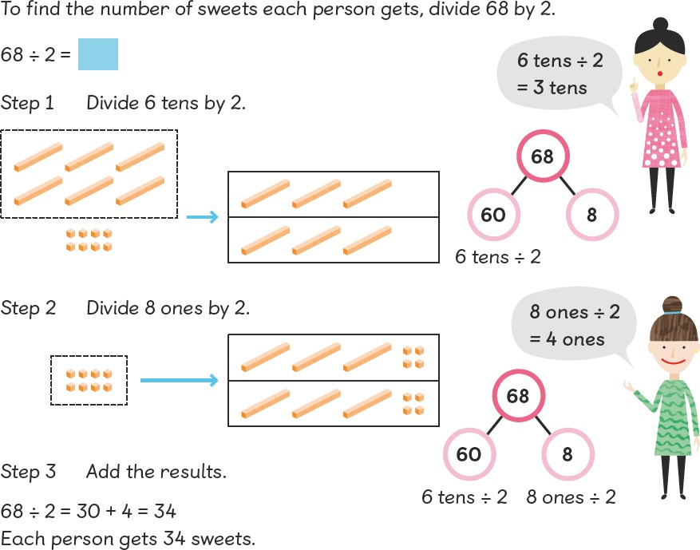

Followed by dividing using renaming, e.g.

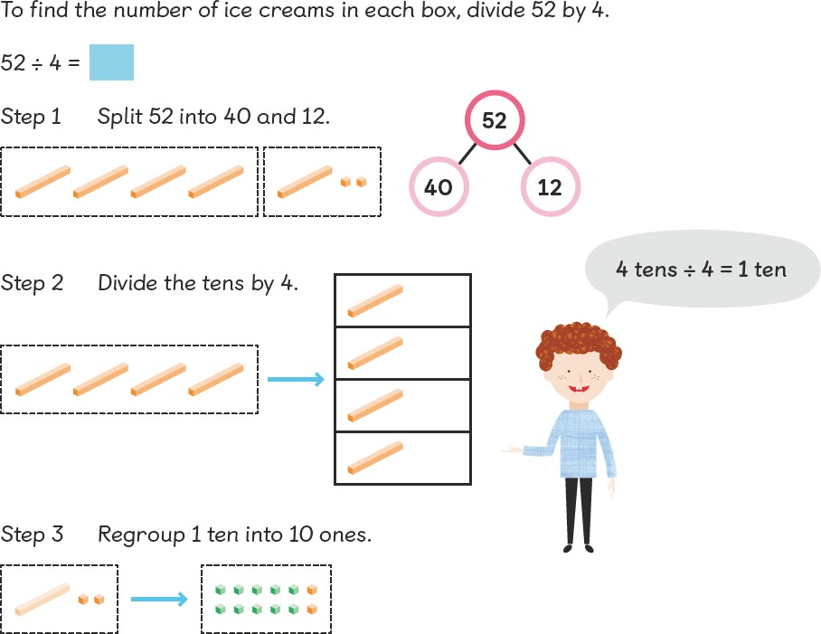

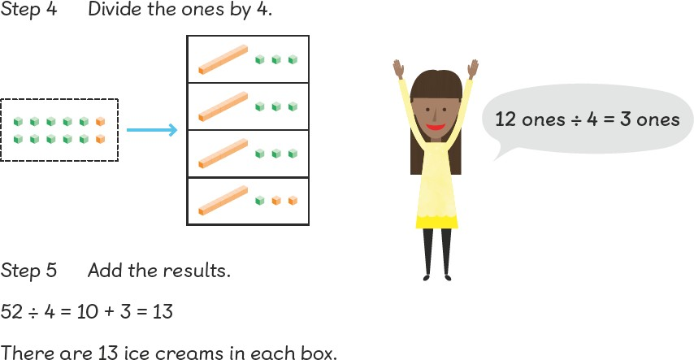

Children should be able to solve real life problems including those with money and measures. They need to be able to make decisions about what to do with remainders after division and round up or down accordingly
Y4
Y5
End of Year Objective:
Divide numbers up to 3 digits by a one-digit number using the formal written method of short division and interpret remainders appropriately for the context.
Children will continue to develop their use of grouping (repeated subtraction), sharing and renaming to solve division problems.

Children will continue to solve problems using grouping and sharing with remainders, interpreting remainders, e.g.
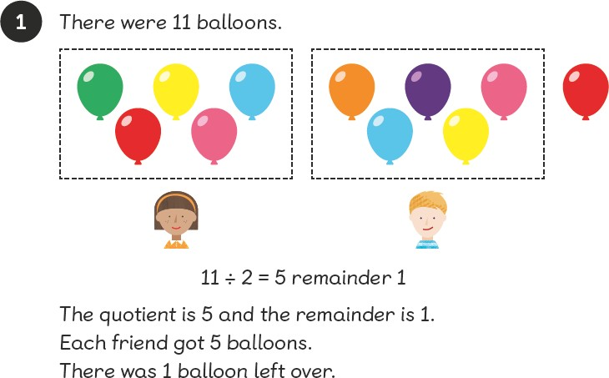

They will begin to formalise their thinking using bar modelling.

Children will solve division problems by building on Year 3 work on division by renaming, moving onto the formal method:

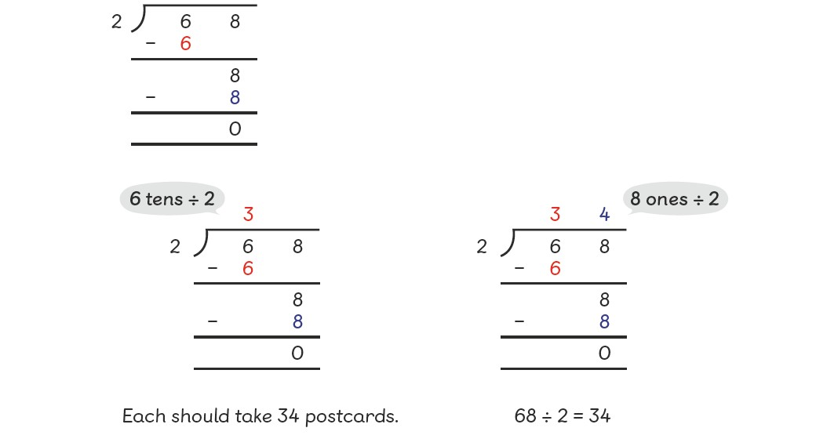
This method can be developed further to divide 3 digit numbers, e.g.

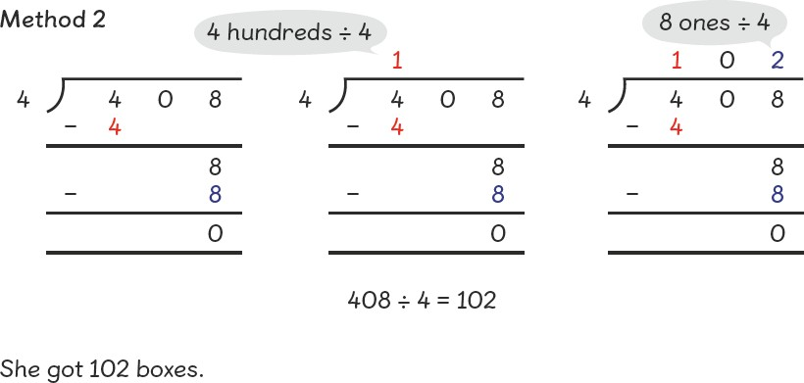
Y5
End of Year Objective:
Divide numbers up to 4 digits by a one-digit number using the formal written method of short division and interpret remainders appropriately for the context.
Year 5 will continue to develop methods learnt in Year 4, including problems with remainders.

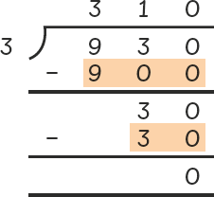

Children should be able to solve real life problems including those with money and measures. They need to be able to make decisions about what to do with remainders after division and round up or down according

Y6
End of Year Objective:
Divide numbers up to 4 digits by a two-digit number using the formal written method of short division where appropriate, interpreting remainders according to the context.
Use written division methods in cases where the answer has up to two decimal places.

Year 6 will continue to practice and develop their methods from Year 5 to divide by a 2 digit number, including using bar modelling to solve division problems. Children should be able to solve real life problems including those with money and measures. They need to be able to make decisions about what to do with remainders after division and round up or down accordingly.


