Pupil premium strategy statement - Chorley St Peter’s

This statement details our school’s use of pupil premium (and recovery premium for the 2022 to 2023 academic year) funding to help improve the attainment of our disadvantaged pupils.

It outlines our pupil premium strategy, how we intend to spend the funding in this academic year and the effect that last year’s spending of pupil premium had within our school.

School overview
Detail | Data
School name | St. Peter’s C.E. Primary School
Number of pupils in school | 302
Proportion (%) of pupil premium eligible pupils | 87 children – 28.81%
Academic year/years that our current pupil premium strategy plan covers (3 year plans are recommended) | January 2022 – January 2025
Date this statement was published | January 22
Date last reviewed | September 23
Date on which it will be reviewed | September 24
Statement authorised by | R. Brown
Pupil premium lead | N.Ward
Governor / Trustee lead | L Benney
Funding overview
Detail | Amount
Pupil premium funding allocation this academic year | £ 138,765.00
Recovery premium funding allocation this academic year | £ 6887.50
Pupil premium funding carried forward from previous years (enter £0 if not applicable) | £ 0
Total budget for this academic year  If your school is an academy in a trust that pools this funding, state the amount available to your school this academic year | £ 145,653.50

Part A: Pupil premium strategy plan

Statement of intent
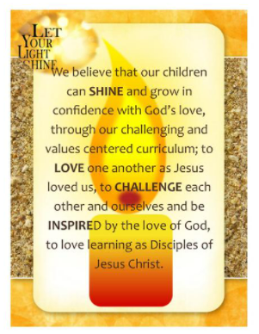
Here at St. Peter’s we aim for all our learners, irrespective of background, to make good progress and enjoy their primary school experience through inspired teaching and through building rewarding relationships with adults and children alike. Together, we will face external challenges to support disadvantaged pupils to achieve this goal and ensure the progress of already high attainers. At St. Peter’s our strong and distinctive Christian ethos is rooted in the life of our school and through our motto to love, challenge and inspire within our school and beyond.
With dedicated staff, already in place, we support vulnerable children who may have involvement from social workers and other care professionals. High quality teaching is essential to ensure excellent progress for disadvantaged children as reinforced by the Sutton Trust 2011.
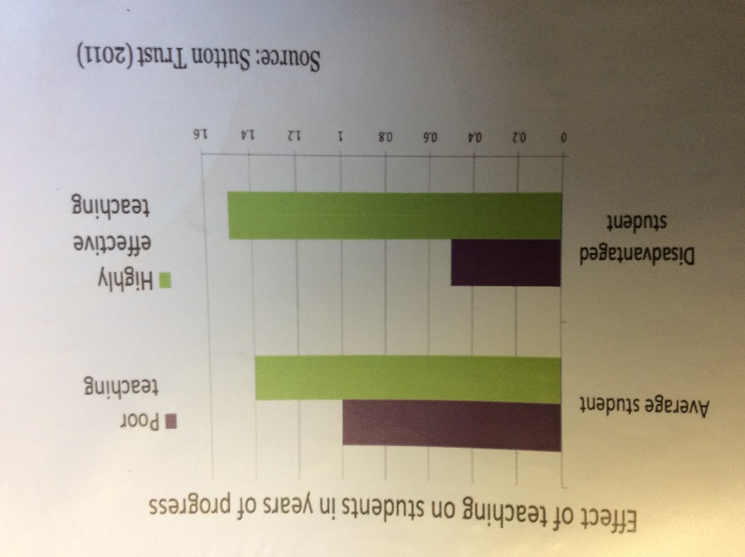

Highly effective teaching will obviously impact on the whole school community. Our aim is to close the gap between our disadvantaged and non-disadvantaged and for our children to achieve age related expectations and greater depth when possible in all areas.
Our approach takes into account historical challenges for our school which sits within a recognised area of deprivation. We are committed to recognising each child’s circumstances and understand each child’s barriers to learning. We are committed to working with all our families to support and alleviate these barriers. All our staff know and understand this vision and play their part in supporting each child from EYFS to Year 6.
Our approach needs to be flexible, to try any and all possible ideas and interventions which may influence the progress of a disadvantaged child especially including early interventions with our youngest children who on average enter our school below age-related expectations in oracy. The culture within St. Peter’s is to raise expectations; of teaching, of what our children can achieve and how they can build on their Primary experience throughout their lives.
Our approach is a holistic manner to ensure disadvantaged pupils are challenged in the work that they’re set, staff members act early to intervene at the point need is identified and we adopt a whole school approach in which all staff take responsibility for disadvantaged pupils’ outcomes and raise expectations of what they can achieve. We identify that we are laying the foundation for our disadvantaged pupils for them to build on throughout their lives.

Challenges

This details the key challenges to achievement that we have identified among our disadvantaged pupils.
Challenge number | Detail of challenge
1 | Assessments, observations, and discussions with pupils indicate underdeveloped oral language skills and vocabulary gaps among many disadvantaged pupils. These are evident from Reception and in general, are more prevalent among our disadvantaged pupils than their peers.
2 | Assessments, observations, and discussions with pupils suggest disadvantaged pupils generally have greater difficulties with phonics than their peers. This negatively impacts their development as readers.
3 | Internal assessments indicate that maths attainment among disadvantaged pupils is below that of non-disadvantaged pupils but which steadily improves through KS2.
4 | Internal assessments indicate that reading attainment among disadvantaged pupils is below that of non-disadvantaged pupils but which steadily improves through KS2.
5 | Internal assessments indicate that writing attainment among disadvantaged pupils is below that of non-disadvantaged pupils:
6 | Observations and discussions with children evidenced the need to continue to develop the emotional stamina and well-being of disadvantaged pupils. There is a need to promote aspirational self-awareness.
7 | Securing parental engagement and raising aspirations for some children.
8 | Persistent absence for 2022-23 recorded 5.96% compared to the National Average of 22.3%

Intended outcomes
This explains the outcomes we are aiming for by the end of our current strategy plan, and how we will measure whether they have been achieved.
Intended outcome | Success criteria
Improved oral language skills and vocabulary among disadvantaged pupils. | Assessments and observations indicate significantly improved oral language among disadvantaged pupils. This is evident within engagement in lessons, participation in Talk Boost, Bug Club Vocabulary, Neli, IDL, continuous provision to promote oracy, all staff modelling reading to children daily (age appropriate texts), reading strategies such as repeated reading/ echo reading/smooth reading, daily reading promoted through guided reading and whole class reading, reading interventions, PP Play Project to promote language and peer interaction (adult led), rehearsed performance of poetry and storytelling. ‘Read with Me’ bags for children to take home in Reception for additional story time and to promote parental engagement.
Improved access to phonics, targeted additional phonics | Attainment in phonics improves through a consistent approach to teaching phonics throughout KS1. Additional adults for phonic sessions throughout KS1, Bounce Back Phonics in Y2 and Y3, parental workshops by EYFS staff and KS1. ‘Phonics Play’ bags for children to take home in Y1 for additional Phonic activity time. The Phonics Tracker is used throughout EYFS and KS1 to identify attainment and swift intervention where required.
Improved maths attainment for disadvantaged pupils at the end of KS1 and KS2. | KS1 and KS2 maths outcomes in 2023-24 show that more disadvantaged pupils met the expected standard.
Improved reading attainment among disadvantaged pupils. | KS1 and KS2 reading outcomes in 2023-24 show that more disadvantaged pupils met the expected standard.
Improved writing attainment | KS1 and KS2 writing outcomes in 2023-24 show that more disadvantaged pupils met the expected standard.
Improvements to children’s emotional well-being, stamina and positive outlook for the future. | Children are inspired and interested in their learning and know the benefits of working hard and achieving. Our Careers Day highlighted the range of careers available through hard work and dedication. Their expectations of life are positive.
Positive relationships with parents are nurtured. | Parents are even more engaged in supporting the learning of their children and reinforce school’s expectations. Individual barriers are minimised for the children.
Attendance continues to improve for disadvantaged pupils in line with non-disadvantaged. | Attendance figures raise towards National Average of 97%

Activity in this academic year
This details how we intend to spend our pupil premium (and recovery premium funding) this academic year to address the challenges listed above.

Teaching (for example, CPD, recruitment and retention)
Budgeted cost: £ 96,844.00
Activity | Evidence that supports this approach | Challenge number(s) addressed
Retain and recruit extra teaching staff to lower the ratio of teacher: children.  Deployment of the best staff to support disadvantaged pupils.  High quality provision in EYFS with low child/adult ratios (2 classes) to maximise interactions. | EEF Toolkit advocates this on 4 extra tips for maximising the impact of Pupil Premium. | 1-5
Ensure high quality first teaching for all pupils | Lesson observations, book scrutiny, focused walk through, pupil interviews to celebrate high expectations from staff and environment walks.
To teach maths and literacy within single age groups (some of which will be half class size) which means recruiting additional teachers. | EEF Toolkit advocates this on 4 extra tips for maximising the impact of Pupil Premium.  Smaller half sized groups for each year group will facilitate improved learning and intervention possibilities. | 1-5
Purchase of Maths No Problem – mastery maths scheme for Y1-6.  Teacher challenges based on NCTEM resources to further stretch deeper learning. | Point 17 from EEF Toolkit advocates ‘Mastery Learning’.  Mastery learning | EEF (educationendowmentfoundation.org.uk) | 3
Purchase of standardised diagnostic assessments to aid collection, analysis and use of data relating to individual groups | Standardised tests can provide reliable insights into the specific strengths and weaknesses of each pupil to help ensure they receive the correct additional support through interventions or teacher instruction:  Standardised tests | Assessing and Monitoring Pupil Progress | Education Endowment Foundation | EEF | 3-5
Embed dialogic activities across the school curriculum; Talk Boost, Neli, learnt poetry performances, Talk to Write and storytelling in each class, PP Play Project, ‘Read with Me’ bags, ‘Phonics Play’ bags, Minute About Me class opportunities. | There is a strong evidence base that suggests oral language interventions, including dialogic activities such as high-quality classroom discussion, are inexpensive to implement with high impacts on reading:  Oral language interventions | EEF (educationendowmentfoundation.org.uk) | 4
Purchase of a DfE validated Systematic Synthetic Phonics programme to secure stronger phonics teaching for all pupils.  Resources for Y2 and Y3 Bounce Back Phonics and training of staff.  Phonics Tracker Training and purchase | Phonics approaches have a strong evidence base that indicates a positive impact on the accuracy of word reading (though not necessarily comprehension), particularly for disadvantaged pupils:  Phonics | EEF (educationendowmentfoundation.org.uk)  Step into Quality Mark achieved | 2
Enhanced reading opportunities throughout school; staff reading to children, class novels per term, class literacy texts – book each per child, purchase Literacy Tree resources Y1-6, purchase of Pearson’s Guided reading resources for KS2 | EEF Toolkit point 18 high impact strategy – reading comprehension.  Reading comprehension strategies | EEF (educationendowmentfoundation.org.uk) | 4,5
CPD for staff through Yarrow Teaching Alliance and other specific courses | Continued development of teachers’ skills and expectations. EEF Toolkit advocates in depth training of staff. | 1-5

Targeted academic support (for example, tutoring, one-to-one support structured interventions)
Budgeted cost: £ 19,685.50
Activity | Evidence that supports this approach | Challenge number(s) addressed
Additional main intervention groups led by Class teacher and groups for Teaching Assistants. Interventions e.g. Phonics, reading support. All TA’s aware of which children eligible for PP Grant.  Programmes have been written by teachers as well as delivered by the class teacher – additional staff employed to deliver Music lessons to release class teacher for group work. Includes Covid catch up groups.  Timely interventions during lessons 1:1 by class teacher and TA to be reinforced same day if required. | EEF advocates more effective use of interventions, to have a 100% buy in from all staff and that teachers, TA’s know who are PP eligible.  TA Performance Management solely linked to PP children.  EEF Guide to the Best Use of Teaching Assistants  Making Best Use of Teaching Assistants | EEF (educationendowmentfoundation.org.uk) | 1-5
Recruit teacher for 1:1/small group work weekly session for PP+ children | Ensuring all children eligible for the PP Grant have access. | 1-5

Wider strategies (for example, related to attendance, behaviour, wellbeing)
Budgeted cost: £ 29,124
Activity | Evidence that supports this approach | Challenge number(s) addressed
Learning Mentor to work with individuals and groups to help build good relationships between peer groups; 6 week programmes for targeted individuals, Lego therapy, Speech and Language, Therapy Dog, morning duty on KS2 yard, lunch time duties working with children who need additional support and lose of family members.  TA welcome all children in morning, emotional support throughout the day. | Education Endowment Foundation  Social & emotional learning report  Social and emotional learning | EEF (educationendowmentfoundation.org.uk) | 6
Learning Mentor working with parents; parenting sessions, Coffee Morning groups, signposting help and services, Christmas and Food support. | Working alongside Social Services | 7
PSHCE new curriculum embedded throughout school and given higher profile following Covid. Pupil Journals for each Junior child, peer massage, yoga strategies for relaxation and self-control, visitors in school (Covid dependent), being part of the wider community, living in the wider world, Money Matters programme for Y5 and 6, Healthy Aces Club, board games\aa | Education Endowment Foundation  Social & emotional learning report  Social and emotional learning | EEF (educationendowmentfoundation.org.uk)
Attendance monitoring; Learning Mentor monitors attendance and builds bridges with families at risk, attendance agreements, Traffic Light letters, PAST referrals, home visits, children collected by school staff, CPOMS used to track and record individual attendance, certificates and class attendance awards, Breakfast Club to promote punctuality (free sessions given where appropriate), Magic Breakfast for all children (suspended from 1st lockdown March 2020). | Dylan William – ‘attending school is first hurdle to making progress’. | 8

Total budgeted cost: £ 145,653.50

Part B: Review of the previous academic year

Outcomes for disadvantaged pupils
This details the impact that our pupil premium activity had on pupils in the 2022 to 2023 academic year.
SLT consistently monitored learning across the school to ensure high standard of quality first teaching.

Single age classrooms were maintained in the morning – these smaller classes allow further targeting of PP children and higher level of teacher/TA support.

The impact of this is that children are receiving live marking and feedback, misconceptions are caught quickly, and interventions put in place leading to children having a more secure understanding of age related expectations.

Catch up support finances from 2022 continued to be used to target PP children and others who had not accessed any learning during lockdown and they receive Tutor sessions in groups of 6 once a week. Class teachers who know the children created targets from which the tutor has organised learning for each group. This is reviewed on a half termly basis.

Teacher interventions and TA interventions have been accelerated in all classes. Teachers have been given time to plan and create resources for such intervention groups.

The impact of this is targeted children receiving consistent, high quality interventions which is enabling them to close the gap with their peers.

On entry, our EYFS children start with weaker than average oracy skills. To accurately assess their strengths and needs, all children were assessed using the Nuffield Early Language Intervention (NELI).

To address the issue with language and vocabulary, within our curriculum, we have provided the children many opportunities to develop and embed their oracy skills. This has been aided by the introduction of a ‘Read with me’ bag (EYFS) and reading rucksacks (Year 1-6). We also held virtual author events throughout both key stages. World book day was celebrated with dressing up as characters and book themed activities in all classes. A ‘bedtime story’ event was also held in KS1 and EYFS. A reading breakfast was held in EYFS to bring parents in. These were designed to promote reading at home and develop a love of reading for our children.

To further support, develop and embed oracy skills we also provided plenty of opportunities for children to talk. We introduced ‘Minute of me’, allowing children the opportunity to speak out loud about something they felt passionate about. Alongside this, each term, every year group learnt a poem to recite out loud and perform in front of the rest of the school. These activities encourage pupils to articulate themselves and further their use of vocabulary and language.
In KS1, the phonics system was revisited, ensuring it was consistent throughout EYFS and KS1. Teachers delivered interactive sessions to parents, developing their knowledge and encouraging their interaction with phonics. This support will then transfer to their children whilst reading and spelling at home. Phonics bags were given to each Year 1 child to take home. Intervention continues in Year 1 and 2 for those children who did not pass the Year 1 phonics test.

The impact of this is children are developing and strengthening their oracy skills, building confidence in speaking, gaining new vocabulary and becoming more language rich.

Alongside oracy, we developed our curriculum with a focus on writing. The whole teaching staff were given training focused on developing writing skills. Two KS2 staff members were also trained in ‘Talk for writing’ which has been woven into their teaching.

Spelling Bee day event continues to try to encourage learning new and varied vocabulary. Spelling Bee used the essential Spelling List of words for each year group. Ninja vocabulary implemented and embedded throughout the school, which allows children to meet and investigate new vocabulary on a weekly basis.
To further develop and improve early maths skills, our EYFS and KS1 staff were trained in NCETM number program – this has been most effective in EYFS and continues to be used daily.
Extra events continue to be organised to close common gaps in Maths e.g. ‘Rock Around the Clock/fraction Friday’.

The impact of this is children who are participating in new experiences, building self-confidence, closing gaps in their own knowledge whilst enjoying a full, rich and varied curriculum. For example, bringing a pantomime to school to give each child the opportunity to witness a live performance.

As part of our rich curriculum, we provided the children with opportunities outside of our school walls. To support disadvantaged children and their families, these school trips were subsidised, ensuring all children were able to enjoy and learn from these activities. A collection of games, such as connect 4, boggle and top trumps were purchased. This is to promote teamwork and sharing, to improve social skills and develop friendships. In addition, a new outdoor classroom has been built to enable learning to take place outside and give the children new opportunities.
In light of recovery from Covid, the continued issue of children’s mental health was paramount. To support children in their reintroduction to school life, both academically and emotionally, we introduced personal journals via PSHE lessons which the children found enjoyable and did allow them to record their thoughts and feelings, and gave them space to share and alleviate fears. The children also received Yoga sessions, provided free by the NHS. Also, ‘Freddie Fit’ day was held. These promoted physical exercise, highlighting the importance to the children of exercise and how it supports their body and mind. To support children’s physical wellbeing, school took part in many sporting festivals, ‘Learn to ride’ is in place and ‘Bikeability’. This is to ensure life skills are embedded.
Eden Red Vouchers (government funding which replaces child’s free school lunch) continued for disadvantaged children. Funded placements were given at the Chorley School Sports Partnership summer holiday club. This supported our disadvantaged children and their families throughout the school holidays. The school newsletter and dojo were also used to signpost parents/families to support that may be on offer in the local area throughout the holidays.
Trips and visitors into school, as well as our St Peter’s Bucket List, enhance the development of the ‘whole child’ through a range of key experiences.
As part of our wider support for our disadvantaged children, Christmas food parcels were provided to families in need as well as school uniforms and bedding. Presents were also gifted to targeted children, provided to us via Rock FM.
Wrap around care was offered to children and families in need. This supported and encouraged attendance and punctuality for some of our disadvantaged children.
The impact of all the above is that children who are disadvantaged outside of school are not missing any opportunities within school. We foster and develop the whole child and ensure that they feel safe, loved and respected. Positive relationships are formed with families and we work together to support and help with any issues that may arise. School is seen as a welcoming, non-judgemental place where the wellbeing of the child is at the heart of all we do.
Teaching assistants continue to be given more hours to support catch up. They complete interventions with targeted children, particularly our disadvantaged children, for whom the gaps grew.
As well as the vital role our Teaching assistants play in supporting the education of the children, they play the same vital role in the children’s emotional and social development. Following the use of Teaching Assistants at lunchtime due to covid bubbles, it was found that the behaviour incidents dropped. We felt that as the teaching assistants knew the children and understood their stories that we would continue with this.
The impact of this is the number of behaviour incidents at lunchtime remain low.
Alongside all the work being done to support and develop our disadvantaged children, our School Development Plan will continue to address our current situation, identify needs and provide opportunities for all our children to thrive.

