Reading Rucksack
"I'm wondering what to read next."
Matilda, Roald Dahl

Dear Reading Buddy,
Reading will open doors and a world of imagination and I want you to read as much as possible. You have brought home the ‘Reading Rucksack’ and you have chosen a book so relax and enjoy this book together.
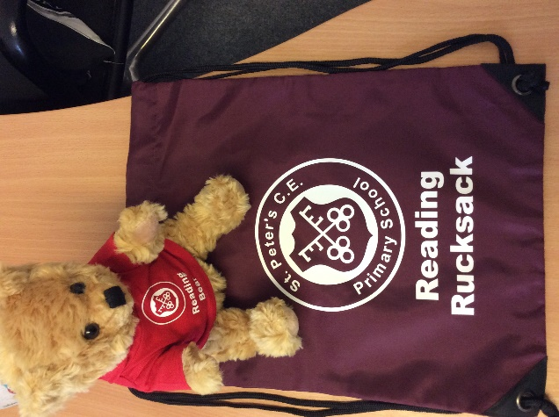
Included in your bag: a hot chocolate, a finger light, the book you have chosen and a bookmark for you to decorate and keep.
I am here, with you, to enjoy the book together or with a family member. We can sit quietly whilst you read to yourself or you can read it to me – I love reading and listening to stories!
Please return the reading rucksack on the day your class teacher has given. Keep the book if you have not finished reading it before you return it.
You will hopefully have enjoyed your hot chocolate, but please return the finger light and, of course, ME so that I can enjoy reading with someone else
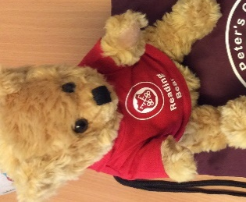
Lots of love,
Reading Bear xxx



