Progression Towards a Written Method for Multiplication

In developing a written method for multiplication, it is important that children understand the concept of multiplication, in that it is:
- repeated addition
They should also be familiar with the fact that it can be represented as an array They also need to understand and work with certain principles, i.e. that it is:
- the inverse of division
- commutative i.e. 5 x 3 is the same as 3 x 5
- associative i.e. 2 x 3 x 5 is the same as 2 x (3 x 5)

YR
Early Learning Goal:
Children solve problems, including doubling.

Children are encouraged to develop a mental picture of the number system in their heads to use for calculation. They should experience practical calculation opportunities using a wide variety of equipment, including small world play, role play, counters, cubes etc.

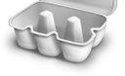
Children may also investigate putting items into resources such as egg boxes, ice cube trays and baking tins which are arrays.
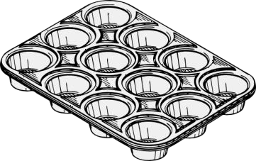
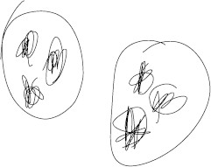
They may develop ways of recording calculations using pictures, etc.

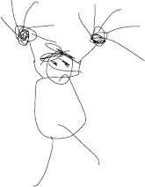
A child’s jotting showing the fingers on each hand as a double.

Y1

A child’s jotting showing double three as three cookies on each plate.

End of Year Objective:
Solve one-step problems involving multiplication by calculating the answer using concrete objects, pictorial representations and arrays with the support of the teacher.
In year one, children will continue to solve multiplication problems using practical equipment and jottings. They may use the equipment to make equal groups or equal rows of objects. Children should see everyday versions of arrays, e.g. egg boxes, baking trays, ice cube trays, wrapping paper etc. and use

this in their learning, answering questions such as 'How many eggs would we need to fill the egg box? How do you know?'

Y2
End of Year Objective:
Calculate mathematical statements for multiplication (using repeated addition) and write them using the multiplication (x) and equals (=) signs.

Children should understand and be able to calculate multiplication as repeated addition, supported by the use of practical apparatus such as counters or cubes. e.g.



5 x 3 can be shown as five groups of three with counters, either grouped in a random pattern, as below:




or in a more ordered pattern, with the groups of three indicated by the border outline:

Children should then develop this knowledge to show how multiplication calculations can be represented by an array, (this knowledge will support with the development of the grid method in the future). Again, children should be encouraged to use practical apparatus and jottings to support their understanding, e.g.

5 x 3* can be represented as an array in two forms (as it has commutativity):



5 + 5 + 5 = 15

3 + 3 + 3 + 3 + 3 = 15

*For mathematical accuracy 5 x 3 is represented by the second example above, rather than the first as it is five, three times. However, because we use terms such as 'groups of' or 'lots of', children are more familiar with the initial notation. Once children understand the commutative order of multiplication the order is irrelevant).

Y3
End of Year Objective:
Write and calculate mathematical statements for multiplication using the multiplication tables that they know, including for two-digit numbers times one-digit numbers, progressing to formal written methods.*

*Although the objective suggests that children should be using formal written methods, the National Curriculum document states “The programmes of study for mathematics are set out year-by-year for key stages 1 and 2. Schools are, however, only required to teach the relevant programme of study by the end of the key stage.
Within each key stage, schools therefore have the flexibility to introduce content earlier or later than set out in the programme of study.” p4

It is more beneficial for children’s understanding to go through the expanded methods of calculation as steps of development towards a formal written method.

Initially, children will continue to use arrays where appropriate linked to the multiplication tables that they know (2, 3, 4, 5, 8 and 10), e.g.

As they progress to multiplying a two-digit number by a single digit number, children should use their knowledge of partitioning two digit numbers into tens and units/ones to help them. For example, when calculating 13 x 3, children could be shown how the array is partitioned so that one array has ten columns and the other four.





10 3

This allows children to identify that the first array shows 10 x 3 and the second array shows 3 x 3. This can be represented using the following diagram:

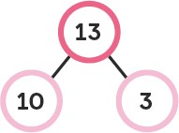

These can then be added to calculate the answer: (3 x 10) + (3 x 3)
= 30 + 9

= 39

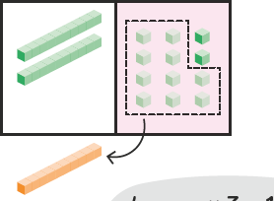
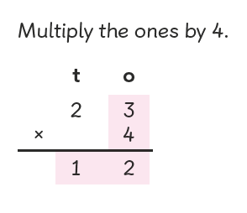
This method can be developed into a compact method of multiplication using the following steps: Step 1

Step 2
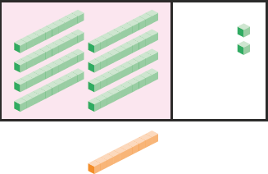
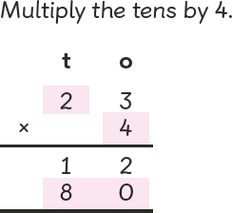

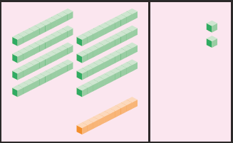
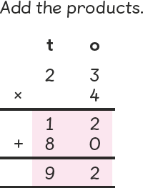
Step 3

Y4
End of Year Objective:
Multiply two-digit and three-digit numbers by a one-digit number using formal written layout.
In Year 4, children will continue to use the methods that they learnt in Year 3. Rather than using base 10 materials, they can use place value counters to represent the array.

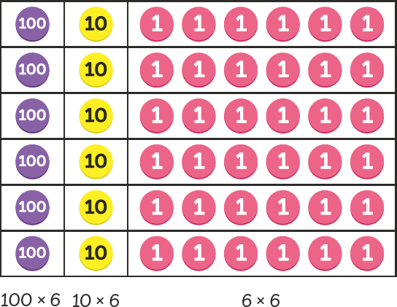

Y5
End of Year Objective:
Multiply numbers up to 4 digits by a one- or two-digit number using a formal written method, including long multiplication for two-digit numbers.
Children will develop their knowledge of multiplication to include multiplying numbers with up to four digits by one- or two-digit numbers.

When learning to multiply by a two-digit number, this may be linked back to children’s knowledge of arrays:

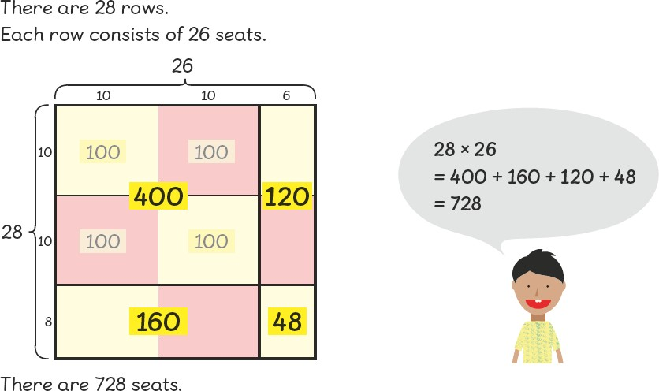

368 x 6

Th H T U
1 1
x | 300 | 60 | 8 |  | 1800
 |  |  |  | + | 360
6 | 1 800 | 360 | 48 | + | 48
 |  |  |  |  | 2208

3 6 8
x 6
4 8 (8 x 6)
3 6 0 (60 x 6)
+ 1 8 0 0 (300 x 6)

Th H T U
1 1
3 6 8
x 6
4 8 (8 x 6)
3 6 0 (60 x 6)
+ 1 8 0 0 (300 x 6)

becomes

Th H T U
4 4
3 6 8
x 6 2 2 0 8
21 2 0 8

21 2 0 8
The place value columns are labelled to ensure children understand the size of the partitioned digits in the original number(s) and in the answer.
It is vital that the teacher models the correct language when explaining the process of the compact method.
The example shown should be explained as:
“Starting with the least significant digit… 8 multiplied by 6 is 48, put 8 in the units and carry 4 tens (40).
6 tens multiplied by 6 are 36 tens. Add the 4 tens carried over to give 40 tens (which is the same as 4 hundreds and 0 tens). Put 0 in the tens place of the answer and carry 4 hundreds.
3 hundreds multiplied by 6 are 18 hundreds. Add the 4 hundreds carried over to give 22 hundreds (which is the same as 2 thousands and 2 hundreds). Write 2 in the hundreds place of the answer and 2 in the thousands place of the answer.”

Children should recognise that the answer is close to an estimated answer of 400 x 6 = 2 400

Long multiplication could also be introduced by comparing the grid method with the compact vertical method. Mentally totalling each row of answers is an important step in children making the link between the grid method and the compact method.

x | 600 | 90 | 3 | 1 1
20 | 12000 | 1800 | 60 | = 13 860
4 | 2400 | 360 | 12 | = 2 772 +
16 632

Children should only be expected to move towards this next method if they have a secure understanding of place value. It is difficult to explain the compact method without a deep understanding of place value.

Step 1
TTh Th H T U
3 1
6 9 3
x 2 4
2 7 7 2 (693 x 4)
The example shown should be explained as:
“Starting with the least significant digit… 3 multiplied by 4 is 12; put 2 in the units and carry 1 ten (10).
9 tens multiplied by 4 are 36 tens. Add the 1 ten carried over to give 37 tens (which is the same as 3 hundreds and 7 tens). Put 7 in the tens place of the answer and carry 3 hundreds.
6 hundreds multiplied by 4 are 24 hundreds. Add the 3 hundreds carried over to give 27 hundreds (which is the same as 2 thousands and 7 hundreds). Write 7 in the hundreds place of the answer and 2 in the thousands place of the answer. We have now found the answer to 693 x 4. Step 1 is complete so to avoid confusion later, we will cross out the carried digits 3 and 1.”
Notice this answer can clearly be seen in the grid method example.

Step 2
TTh Th H T U
1 1
6 9 3
x 2 4
2 73 71 2 (693 x 4)
+ 1 3 8 6 0 (693 x 20)

Step 3
TTh Th H T U
6 9 3
x 2 4
2 7 7 2 (693 x 4)
+ 1 3 8 6 0 (693 x 20)
Now we are multiplying 693 by 20. Starting with the least significant digit of the top number… 3 multiplied by 20 is 60. Write this answer in.
90 multiplied by 20 is 1 800. There are no units and no tens in this answer, so write 8 in the hundreds place and carry 1 in the thousands.
600 multiplied by 20 is 12 000. Add the 1 (thousand) that was carried to give 13 000. There are no units, no tens and no hundreds in this answer, so write 3 in the thousands place and 1 in the ten thousands place.

The final step is to total both answers using efficient columnar addition.

1 6 63 31 2
1 1

When using the compact method for long multiplication, all carried digits should be placed below the line of that answer e.g. 3 x 4 is 12, so the 2 is written in the units column and the 10 is carried as a small 1 in the tens column.
This carrying below the answer is in line with the written addition policy in which carried digits are always written below the answer/line.

Y6
End of Year Objective:
Multiply multi-digit numbers up to 4 digits by a two-digit whole number using the formal written method of long multiplication.
Multiply one-digit numbers with up to two decimal places by whole numbers.

By the end of year 6, children should be able to use the grid method and the compact method to multiply any number by a two-digit number. They could also develop the method to be able to multiply decimal numbers with up to two decimal places, but having been introduced to expanded and compact vertical methods in Year 5, it may be appropriate to use the expanded vertical method when introducing multiplication involving decimals.

4.92 x 3
T U . t h 4 . 9 2
x 3
0 . 0 6 (0.02 x 3)
2 . 7 (0.9 x 3)
+ 1 2 (4 x 3)
1 4 . 7 6

becomes

T U . t h 4 . 9 2
x 3 1 4 . 7 6
2

Children should also be using this method to solve problems and multiply numbers, including those with decimals, in the context of money or measures, e.g. to calculate the cost of 7 items at £8.63 each, or the total length of six pieces of ribbon of 2.28m each.

