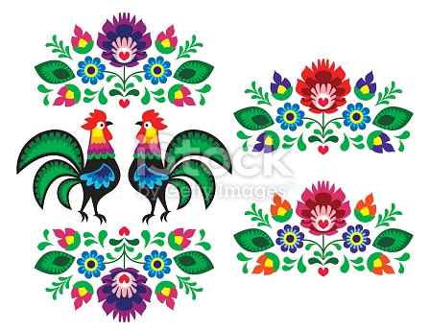
Look at these examples of Polish Folk Art.
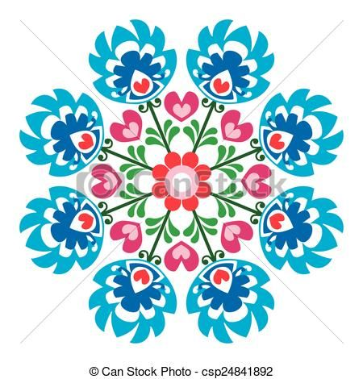
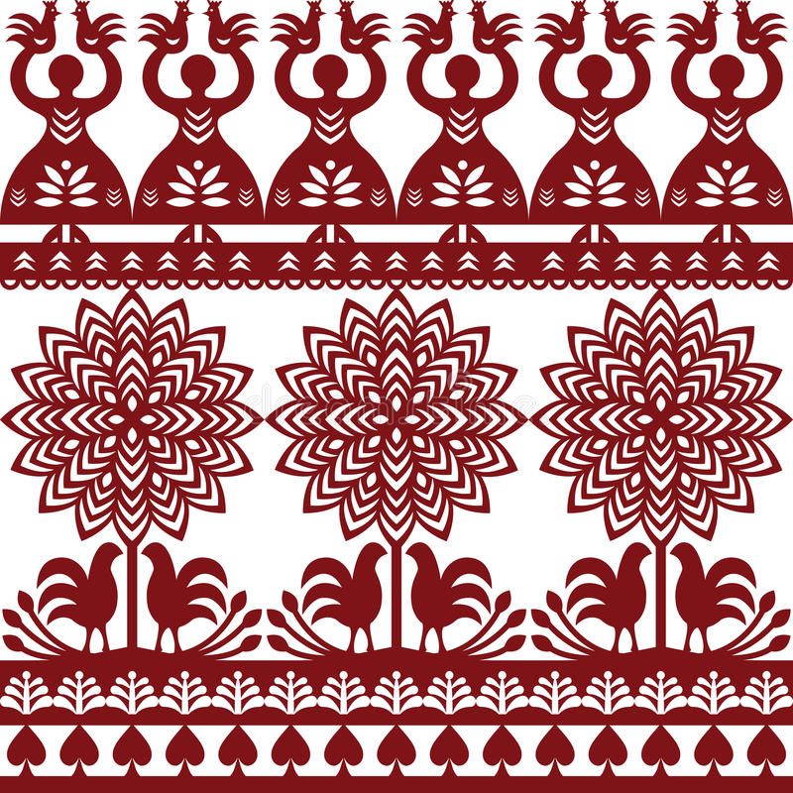

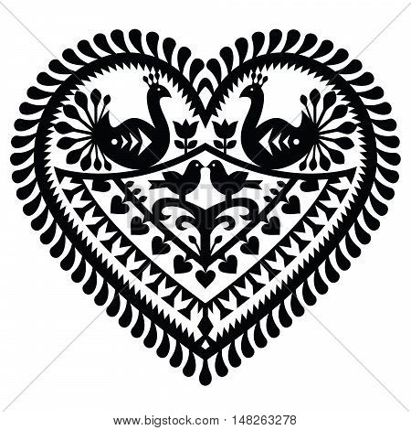

Can you create your own Polish folk art design?
Watch this you tube clip for help on how to draw a folk art tree:
https://www.youtube.com/watch?v=QzDrjht4RQw

