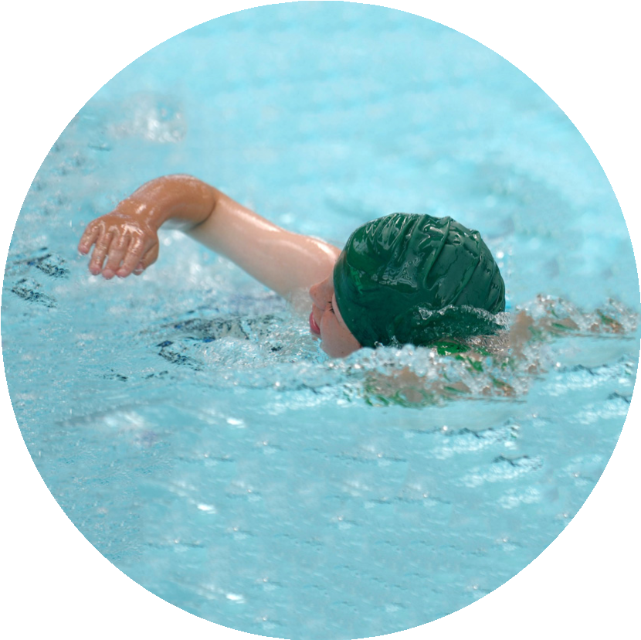
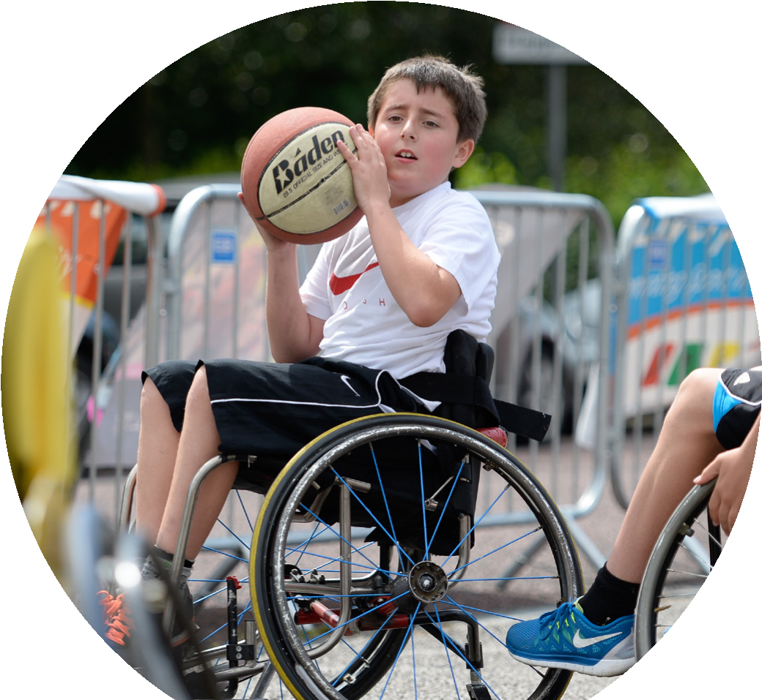
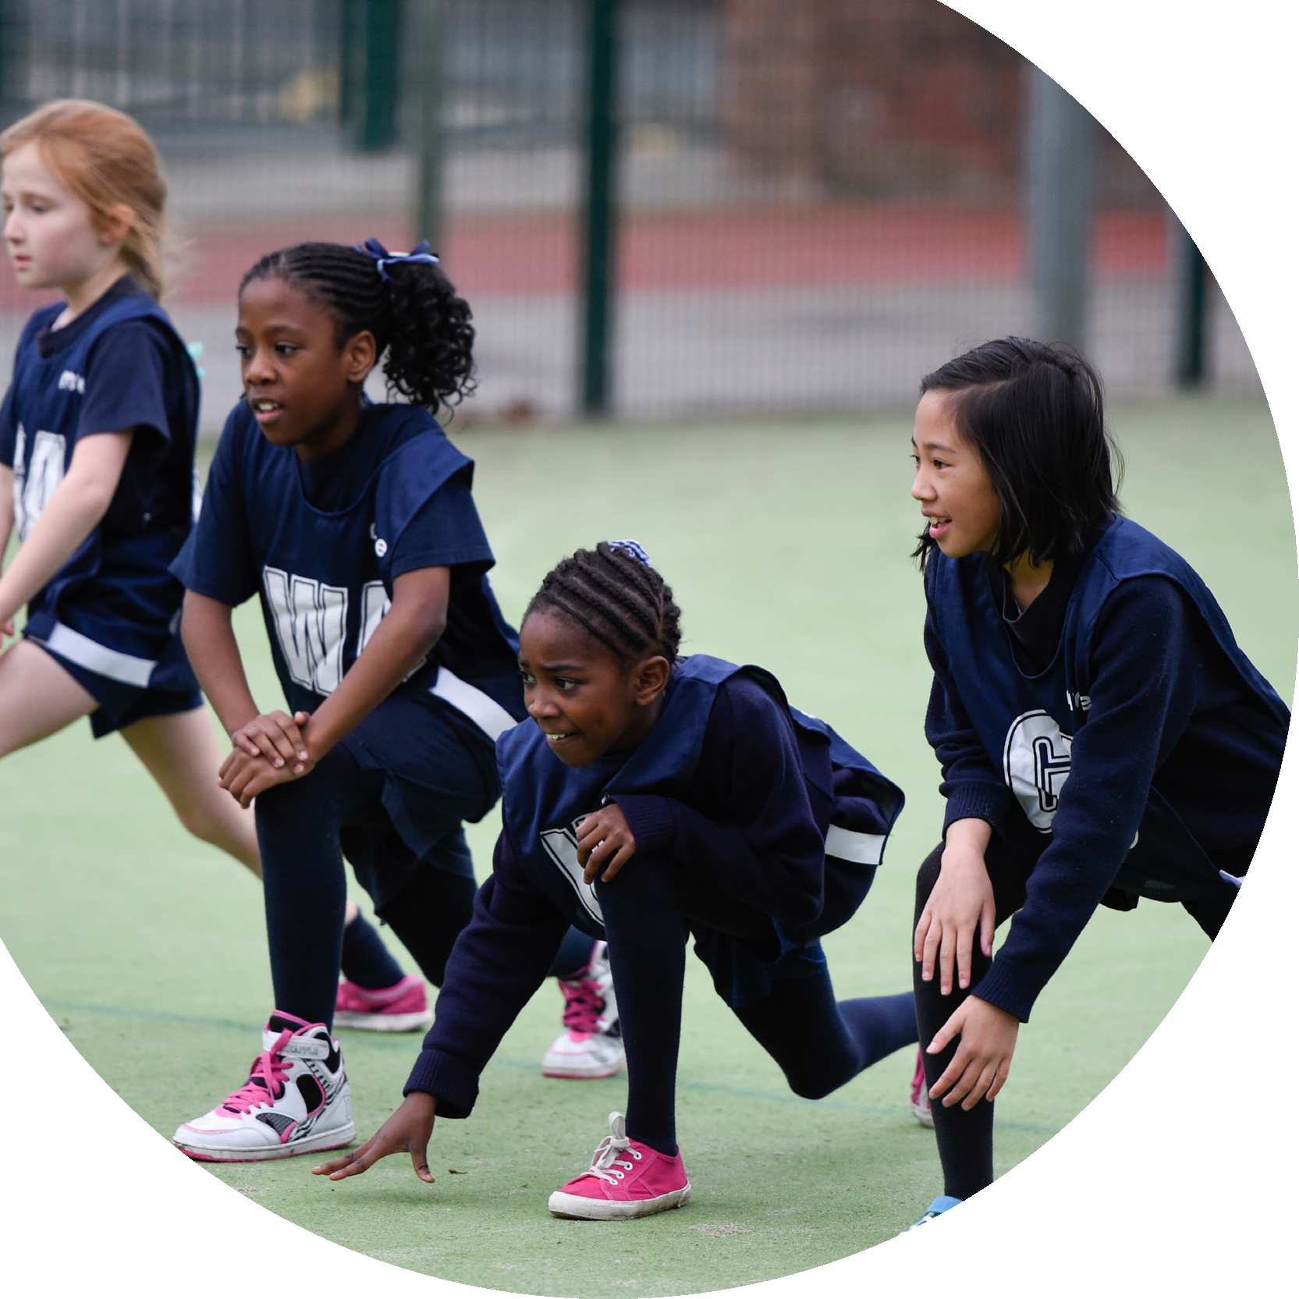


Evidencing the
impact of the
Primary PE and
sport premium

Website Reporting Tool
Revised May 2021
Commissioned by the
Department for Education

Created by

It is important that your grant is used effectively and based on school need. The Education Inspection Framework (Ofsted 2019 p64) makes clear there will be a focus on ‘whether leaders and those responsible for governors all understand their respective roles and perform these in a way that enhances the effectiveness of the school’.
Under the Quality of Education criteria (p41) inspectors consider the extent to which schools can articulate their curriculum (INTENT), construct their curriculum (IMPLEMENTATION) and demonstrate the outcomes which result (IMPACT).
To assist schools with common transferable language this template has been developed to utilise the same three headings which should make your plans easily transferable between working documents.
Schools must use the funding to make additional and sustainable improvements to the quality of Physical Education, School Sport and Physical Activity (PESSPA) they offer. This means that you should use the Primary PE and sport premium to:
- Develop or add to the PESSPA activities that your school already offer

- Build capacity and capability within the school to ensure that improvements made now will benefit pupils joining the school in future years
- The Primary PE and sport premium should not be used to fund capital spend projects; the school’s budget should fund these.
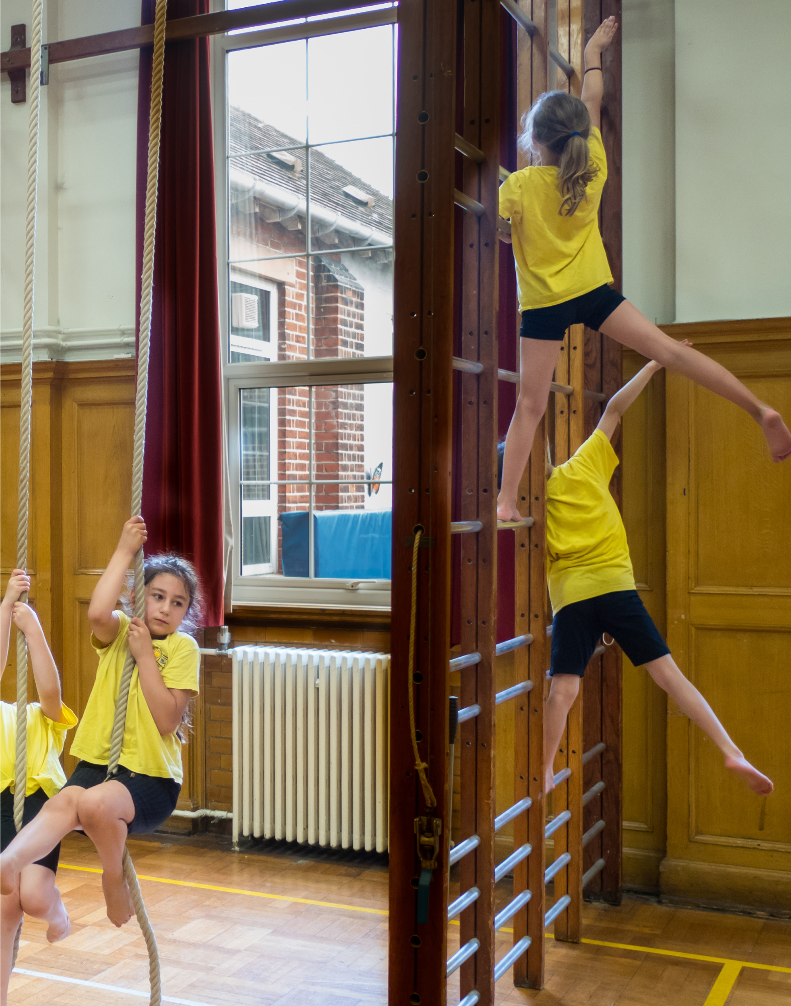
Please visit gov.uk for the revised DfE guidance including the 5 key indicators across which schools should demonstrate an improvement. This document will help you to review your provision and to report your spend. DfE encourages schools to use this template as an effective way of meeting the reporting requirements of the Primary PE and sport premium.
We recommend you start by reflecting on the impact of current provision and reviewing the previous spend.
Schools are required to publish details of how they spend this funding, including any under-spend from 2019/2020, as well as on the impact it has on pupils’ PE and sport participation and attainment by the end of the summer term or by 31st July 2021 at the latest.
We recommend regularly updating the table and publishing it on your website throughout the year. This evidences your ongoing self-evaluation of how you are using the funding to secure maximum, sustainable impact.
Final copy must be posted on your website by the end of the academic year and no later than the 31st July 2021.
To see an example of how to complete the table please click HERE.
Support for review and reflection - considering the 5 key indicators from DfE, what development needs are a priority for your setting and your pupils now and why? Use the space below to reflect on previous spend and key achievements and areas for development.
Please note: Although there has been considerable disruption in 2020 it is important that you publish details on your website of how you spend the funding - this is a legal requirement.
N.B. In this section you should refer to any adjustments you might have made due to Covid-19 and how these will influence further improvement.
Key achievements to date until July 2020: | Areas for further improvement and baseline evidence of need:
Did you carry forward an underspend from 2019-20 academic year into the current academic year?
YES/NO * Delete as applicable
Total amount carried forward from 2019/2020 + Total amount for this academic year 2020/2021 £12,770
Total to be spent by 31st July 2021 £......

Meeting national curriculum requirements for swimming and water safety.
N.B Complete this section to your best ability. For example you might have practised safe self-rescue techniques on dry land which you can transfer to the pool when school swimming restarts.
Due to exceptional circumstances priority should be given to ensuring that pupils can perform safe self rescue even if they do not fully meet the first two requirements of the NC programme of study.
What percentage of your current Year 6 cohort swim competently, confidently and proficiently over a distance of at least 25 metres?  N.B. Even though your pupils may swim in another year please report on their attainment on leaving primary school at the end of the summer term 2021.  Please see note above. | 0% - Due to Covid
What percentage of your current Year 6 cohort use a range of strokes effectively [for example, front crawl, backstroke and breaststroke]?  Please see note above. | 0% - Due to Covid
What percentage of your current Year 6 cohort perform safe self-rescue in different water-based situations? | 0% - Due to Covid
Schools can choose to use the Primary PE and sport premium to provide additional provision for swimming but this must be for activity over and above the national curriculum requirements. Have you used it in this way? | 0% - Due to Covid
Action Plan and Budget Tracking
Capture your intended annual spend against the 5 key indicators. Clarify the success criteria and evidence of impact that you intend to measure to evaluate for pupils today and for the future.

Academic Year: 2020/21 | Total fund allocated: £ | Date Updated:
Key indicator 1: The engagement of all pupils in regular physical activity – Chief Medical Officers guidelines recommend that primary school pupils undertake at least 30 minutes of physical activity a day in school |  |  |  | Percentage of total allocation:
Intent | Implementation |  | Impact
Your school focus should be clear what you want the pupils to know and be able to do and about what they need to learn and to consolidate through practice: | Make sure your actions to achieve are linked to your intentions: | Funding allocated: | Evidence of impact: what do pupils now know and what can they now do? What has changed?: | Sustainability and suggested next steps:
Staff will continue to be supported and offered CPD in supporting the 30 minutes active. Staff will continue to teach two PE Lesson and ensure that the curriculum map is followed. Children are to continue running the daily mile. Staff to receive CDP for one term from a fully qualified coach.  Playground design inputted and accepted – work to be done over the summer. | Two hours PE a week  Daily Mile  Commando Joes  PALS leaders and resources  Playground Improvements | Com. Joes – £500  CSSP – £2660.00  Playground – £20,000 | Variety of sports being taught within the two hours taught. Daily fresh air and head space. Children learning to work more as a team through the Commando Joes' program, learning more about themselves and their leadership skills.  New playground equipment being installed on all three playgrounds to improve gross motor skills. – Next Summer | Continue with the Commando Joes.  Continue mile a day.  Continue to run ambassadors courses. try to gain more interest, as only had 4 applicants.  Train up year 6s to look after new equipment and areas.
Key indicator 2: The profile of PESSPA being raised across the school as a tool for whole school improvement |  |  |  | Percentage of total allocation:
Intent | Implementation |  | Impact
Your school focus should be clear what you want the pupils to know and be able to do and about what they need to learn and to consolidate through practice: | Make sure your actions to achieve are linked to your intentions: | Funding allocated: | Evidence of impact: what do pupils now know and what can they now do? What has changed?: | Sustainability and suggested next steps:
Use of curriculum map.  Staff to follow the subject and teach accordingly.  More children to be active within PE and after school activities in the range of clubs offered.  Staff to use APP to monitor lessons and progress. | Curriculum Map  Year 2 assessments  Health Leads  PE App introduced and implemented.  Celebration board - up to date. Newsletter updates. PE | CSSP – £285.00  (after school club money inc in CSSP £2660) | More structured lessons, staff know what it is they are teaching and when.  Also what skills they are focusing on.  Lesson plans easily accessible through the app.  Assessment easily accessed through it too.  Parent's more aware of our achievements through the newsletter, leading to more interest in clubs. | Try to promote clubs throughout the skills as same faces keep showing up.  Relaunch APP in September to provide more opportunity for assessment and progression.  Keep updating sports' corner in newsletter.  Start to promote clubs in advance to gain more interest.

Key indicator 3: Increased confidence, knowledge and skills of all staff in teaching PE and sport |  |  |  | Percentage of total allocation:
Intent | Implementation |  | Impact
Your school focus should be clear what you want the pupils to know and be able to do and about what they need to learn and to consolidate through practice: | Make sure your actions to achieve are linked to your intentions: | Funding allocated: | Evidence of impact: what do pupils now know and what can they now do? What has changed?: | Sustainability and suggested next steps:
Courses and CPD offered from CSSP to enhance subject knowledge and confidence in teaching PE.  Create a wider knowledge of fitness throughout the school.  PLT days and support meeting with CSSP  Youth Sport trust membership. | CSSP to offer CPD to all staff throughout the year.  CPD and courses offered to staff where needed. | Equipment –  CSSP - £800 | LS attended PLT days, helped provide information leading to a silver place at singing competition.  Better equipment ordered for lessons and clubs.  Children were able to use the specialised equipment used in competition, leading to a better outcome. | Continue to upgrade equipment and facilities, keeping up to date with CSSP.  Carry on with Freddie Fit. Provide the same football clubs Danny (First Kick) started.  Run 2 football clubs to gain more interest and to promote progression through the years.
Key indicator 4: Broader experience of a range of sports and activities offered to all pupils |  |  |  | Percentage of total allocation:
Intent | Implementation |  | Impact
Your school focus should be clear what you want the pupils to know and be able to do and about what they need to learn and to consolidate through practice: | Make sure your actions to achieve are linked to your intentions: | Funding allocated: | Evidence of impact: what do pupils now know and what can they now do? What has changed?: | Sustainability and suggested next steps:
Additional achievements:  Balance bike, learn to ride and bikeability courses for Reception and Year 6  Gifted and Talented for Year 6  PALs training  Culture workshop with CSSP | Bikeability - Level 1 and 2  Balance bike  Festivals  Gift and Talented  Sports Day  Commando Joes  Colour run. | Bike – £470.00  G&T £200.00  PALS – £150  Culture – £60.00  Festivals – £300.00 | Completed level 1 and 2 bikeability with a 97% pass rate.  Completed the balance bike training.  Had 10 children take part in the gifted and talented programme.2 were successful.  All children took part in a whole school sports day. All children who were spoken to spoke very positively about their experience and can’t wait to do it again.  All the children took part in a Race for Life Colour run. | Choose different children to take part in festivals next year, when they start back up.  Try to get children, who took part in festivals two years ago, to get more involved in clubs next year.  Restart all sports clubs.  Enter as many competitinos as we can.

Key indicator 5: Increased participation in competitive sport |  |  |  |  |  | Percentage of total allocation:
Intent |  | Implementation |  |  | Impact
Your school focus should be clear what you want the pupils to know and be able to do and about what they need to learn and to consolidate through practice: |  | Make sure your actions to achieve are linked to your intentions: | Funding allocated: |  | Evidence of impact: what do pupils now know and what can they now do? What has changed?: | Sustainability and suggested next steps:
To offer a wider range of sporting clubs and activities to children. To try and promote clubs to children who haven't participated before.  TO enter as many intra school competitions as we can.  To take part in virtual competitions when we can.  To complete a COVID safe sports day. |  | Festivals Sports Day Inter and Intra school Comps.  Whole school sports day.  Whole school orienteering competition.  Enter as many competitions as we can. | Competitions – £900.00  Intra competitions – £750.00  Sports Day – £560.00 |  | Sports day was completed and very successful. Feedback from children was all positive.  All children including EYFS took part and enjoyed the orienteering competition.  Unable to enter inter school competitions due to COVID regulations and isolation periods. | Enter all competitions.  Restart the choir and enter the big sing.  Try to get Cheerleading into school.
Signed off by
Head Teacher: | R.Brown
Date: | 16.07.21
Subject Leader: | L.Stephens M. Eastham
Date: | 16.07.21
Governor: | Mr David Roberts
Date: | 17.07.21

