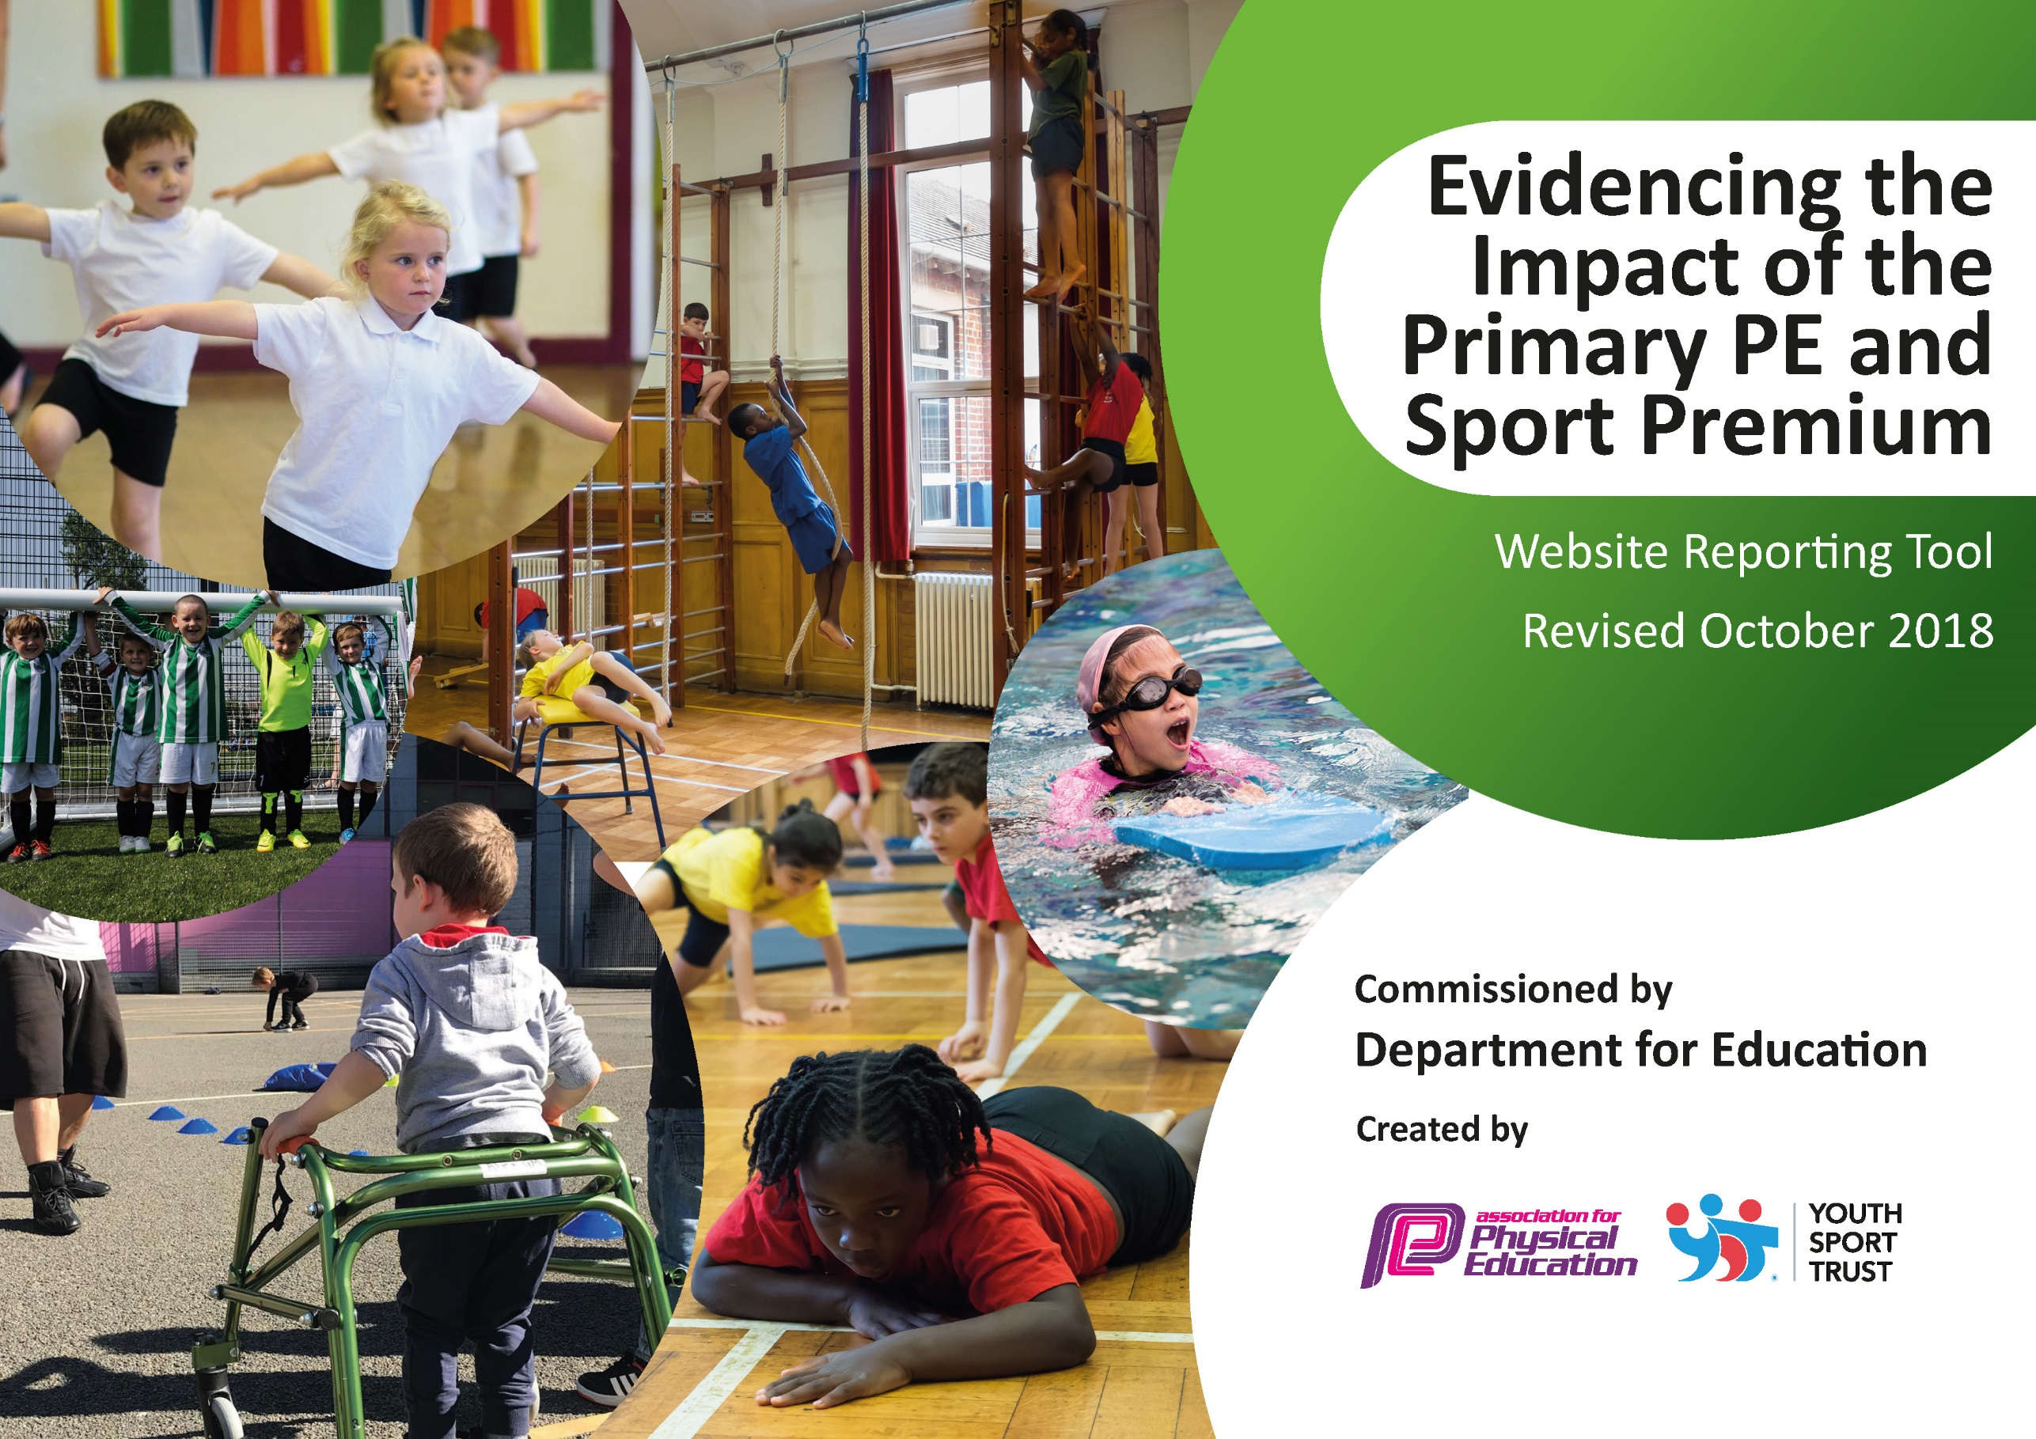
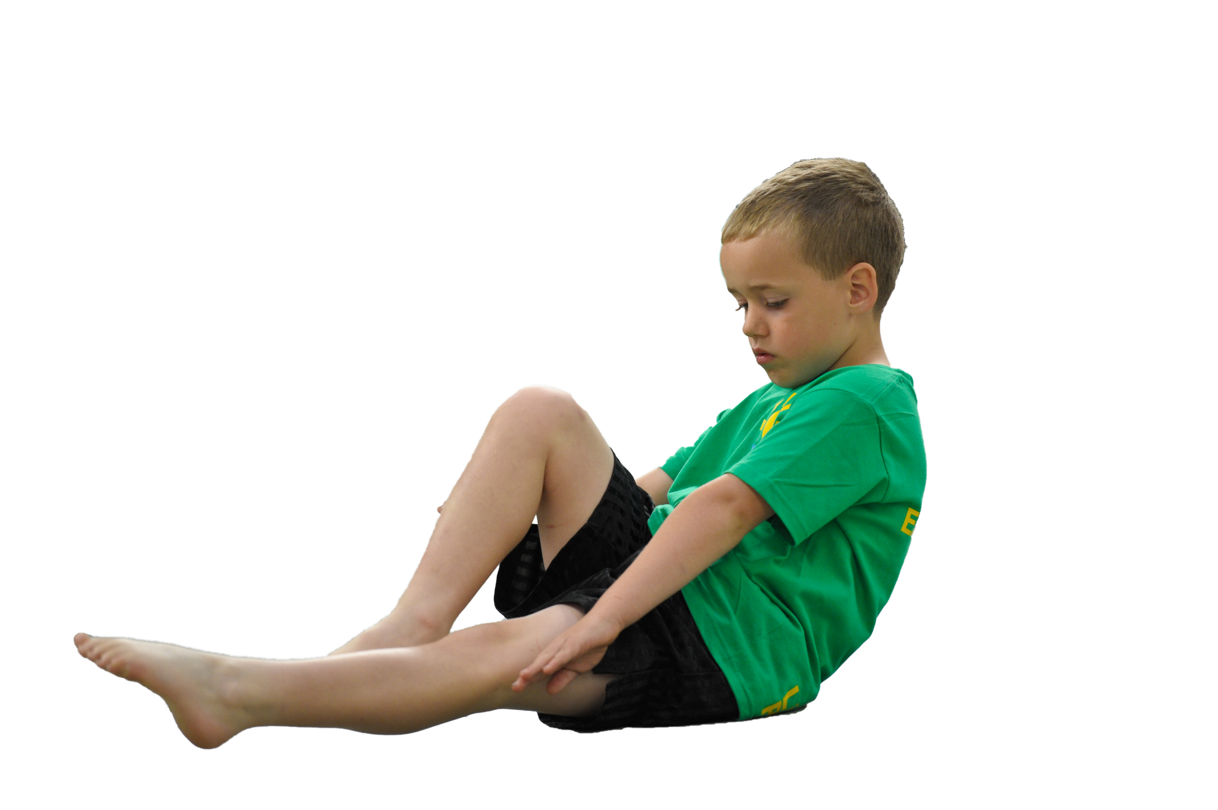
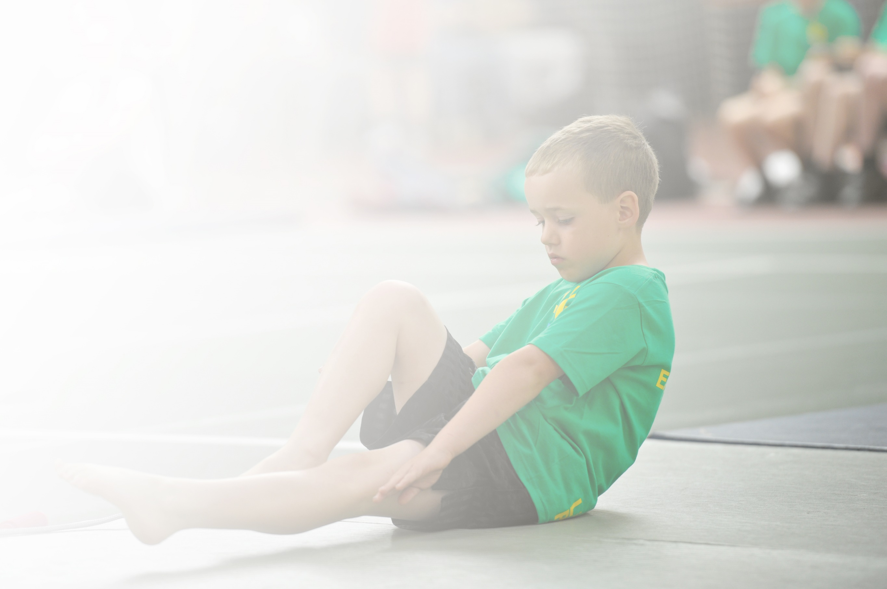
Schools must use the funding to make additional and sustainable improvements to the quality of Physical Education, Sport and Physical Activity (PESPA) they offer. This means that you should use the Primary PE and Sport Premium to:

- Develop or add to the PESPA activities that your school already offer
- Build capacity and capability within the school to ensure that improvements made now will benefit pupils joining the school in future years

Please visit gov.uk for the revised DfE guidance including the 5 key indicators across which schools should demonstrate an improvement. This document will help you to review your provision and to report
your spend. DfE encourages schools to use this template as an effective way of meeting the reporting requirements of the Primary PE and Sport Premium.

We recommend you start by reflecting on the impact of current provision and reviewing the previous
spend. Under the Ofsted Schools Inspection Framework, inspectors will assess how effectively leaders use the Primary PE and Sport Premium and measure its impact on outcomes for pupils, and how effectively governors hold them to account for this.

Schools are required to publish details of how they spend this funding as well as on the impact it has on pupils’ PE and sport participation and attainment by the end of the summer term or by 31 July 2019 at the
latest.
We recommend regularly updating the table and publishing it
on your website throughout the year, as evidence of your
ongoing review into how you are using the money to
secure maximum, sustainable impact. To see an
example of how to complete the table please
click HERE.

Support for review and reflection - considering the 5 key indicators from DfE, what development needs are a priority for your setting and your students now and why? Use the space below to reflect on previous spend, identify current need and priorities for the future.

Key achievements to date: | Areas for further improvement and baseline evidence of need:
- Wider range of sports offered to encourage less active children.  - Wider range of competitions and festivals entered resulting in winning the Chorley sports partnership partition award.  - Sports ambassadors and Health champions were implemented and trained to work with staff and assist in running C4L and sports groups.  - Bike ability was delivered with 95% of year 6 children partaking and passing at level 1&2.  - Learn to ride scheme was delivered to all reception children successfully.  - All year 5’s where trained to become PALS allowing a range of lunchtime physical activities to take place.  - C4L club continued with great success.  - Staff were offered CPD to ensure high quality P.E continued to be taught.  - Transport was used to take children to competitions.  - We won whole school P.E impact at the end of year awards. | - To offer new and NQT staff with CPD and team teaching in P.E  - To offer a wider range of activities and sports clubs to interest children in participation.  - To ensure equipment is replenished and accessible when needed.  - C4L club to continue with greater impact and be offered to 3 separate groups over 3 terms including KS1 to children in line with the obesity strategy.  - KS2 children to take on leadership roles  - To implement intervention groups for fundamental skills e.g. Beam.  - To introduce and pilot the new P.E assessment through IPAD app with KS1.  - Children to become more active during play and lunch times.

Meeting national curriculum requirements for swimming and water safety | Please complete all of the below:
What percentage of your current Year 6 cohort swim competently, confidently and proficiently over a distance of at least 25 metres?  N.B. Even though your children may swim in another year please report on their attainment on leaving  primary school. | 88%
What percentage of your current Year 6 cohort use a range of strokes effectively [for example, front crawl, backstroke and breaststroke]? | 88%
What percentage of your current Year 6 cohort perform safe self-rescue in different water-based situations? | 88%
Schools can choose to use the Primary PE and Sport Premium to provide additional provision for swimming but this must be for activity over and above the national curriculum requirements. Have you used it in this way? | Yes/No

Action Plan and Budget Tracking
Capture your intended annual spend against the 5 key indicators. Clarify the success criteria and evidence of impact that you intend to measure to evaluate for students today and for the future.

Academic Year: 2018/19 | Total fund allocated: £18,800 | Date Updated: 31.07.19
Key indicator 1: The engagement of all pupils in regular physical activity – Chief Medical Officer guidelines recommend that primary school children undertake at least 30 minutes of physical activity a day in school |  |  |  | Percentage of total allocation:
 |  |  |  | %
School focus with clarity on intended impact on pupils: | Actions to achieve: | Funding allocated: | Evidence and impact: | Sustainability and suggested next steps:
Staff will be supported and offered CPD in supporting the 30 mins through an inset led by CSSP in the new academic year. Children will then actively partake in the next school year within the school day when best fit. | CPD given to all staff on daily mile and keeping children active within the classroom. | £200 | All staff trained and have implemented this within each classroom when best fit.  Heat maps completed to show more active classrooms. | To continue to ensure children are more active in the classroom and within school time.
Key indicator 2: The profile of PESSPA being raised across the school as a tool for whole school improvement |  |  |  | Percentage of total allocation:
 |  |  |  | %
School focus with clarity on intended impact on pupils: | Actions to achieve: | Funding allocated: | Evidence and impact: | Sustainability and suggested next steps:
New curriculum map devised for the whole school to enable all coverage of P.E subjects are covered.  More children will be actively involved within sport and P.E and a wider range of clubs offered. | - Create new curriculum map  - Offer more activities and clubs.  - Enter more competitions. | £9,426.00 | - New curriculum map created and implemented throughout school.  - More clubs offered and children participated.  - Won whole school impact and participation award at end of year award ceremony. | To continue to follow whole school curriculum map and offer children with a range of sporting activities and competitions.

Key indicator 3: Increased confidence, knowledge and skills of all staff in teaching PE and sport |  |  |  | Percentage of total allocation:
 |  |  |  | %
School focus with clarity on intended  impact on pupils: | Actions to achieve: | Funding  allocated: | Evidence and impact: | Sustainability and suggested  next steps:
Courses and CPD offered from CSSP to enhance subject knowledge and confidence of teaching P.E. | CPD offered to staff where needed | Part of CSSP money. | Teachers are confident in delivering P.E lessons showing good subject knowledge. | To offer new staff training where needed.
Key indicator 4: Broader experience of a range of sports and activities offered to all pupils |  |  |  | Percentage of total allocation:
 |  |  |  | %
School focus with clarity on intended  impact on pupils: | Actions to achieve: | Funding  allocated: | Evidence and impact: | Sustainability and suggested  next steps:
Additional achievements:  To offer a wider range of sporting activities and clubs to children and enter more competitions and festivals. | To offer a wider range of sporting activities and clubs to children and enter more competitions and festivals. | Part of money allocated to cssp. | More clubs where offered, more competition and festivals entered.  Won participation award and whole school impact award at the cssp awards evening. | To continue to offer a wider range of sporting activities and clubs to children and enter more competitions and festivals.
Key indicator 5: Increased participation in competitive sport |  |  |  | Percentage of total allocation:
 |  |  |  | %
School focus with clarity on intended  impact on pupils: | Actions to achieve: | Funding  allocated: | Evidence and impact: | Sustainability and suggested  next steps:
To offer a wider range of sporting activities and clubs to children and enter more competitions and festivals. | To offer a wider range of sporting activities and clubs to children and enter more competitions and festivals. | Part of money allocated to cssp. | More clubs where offered, more competition and festivals entered.  Won participation award and whole school impact award at the cssp awards evening. | To continue to offer a wider range of sporting activities and clubs to children and enter more competitions and festivals.

