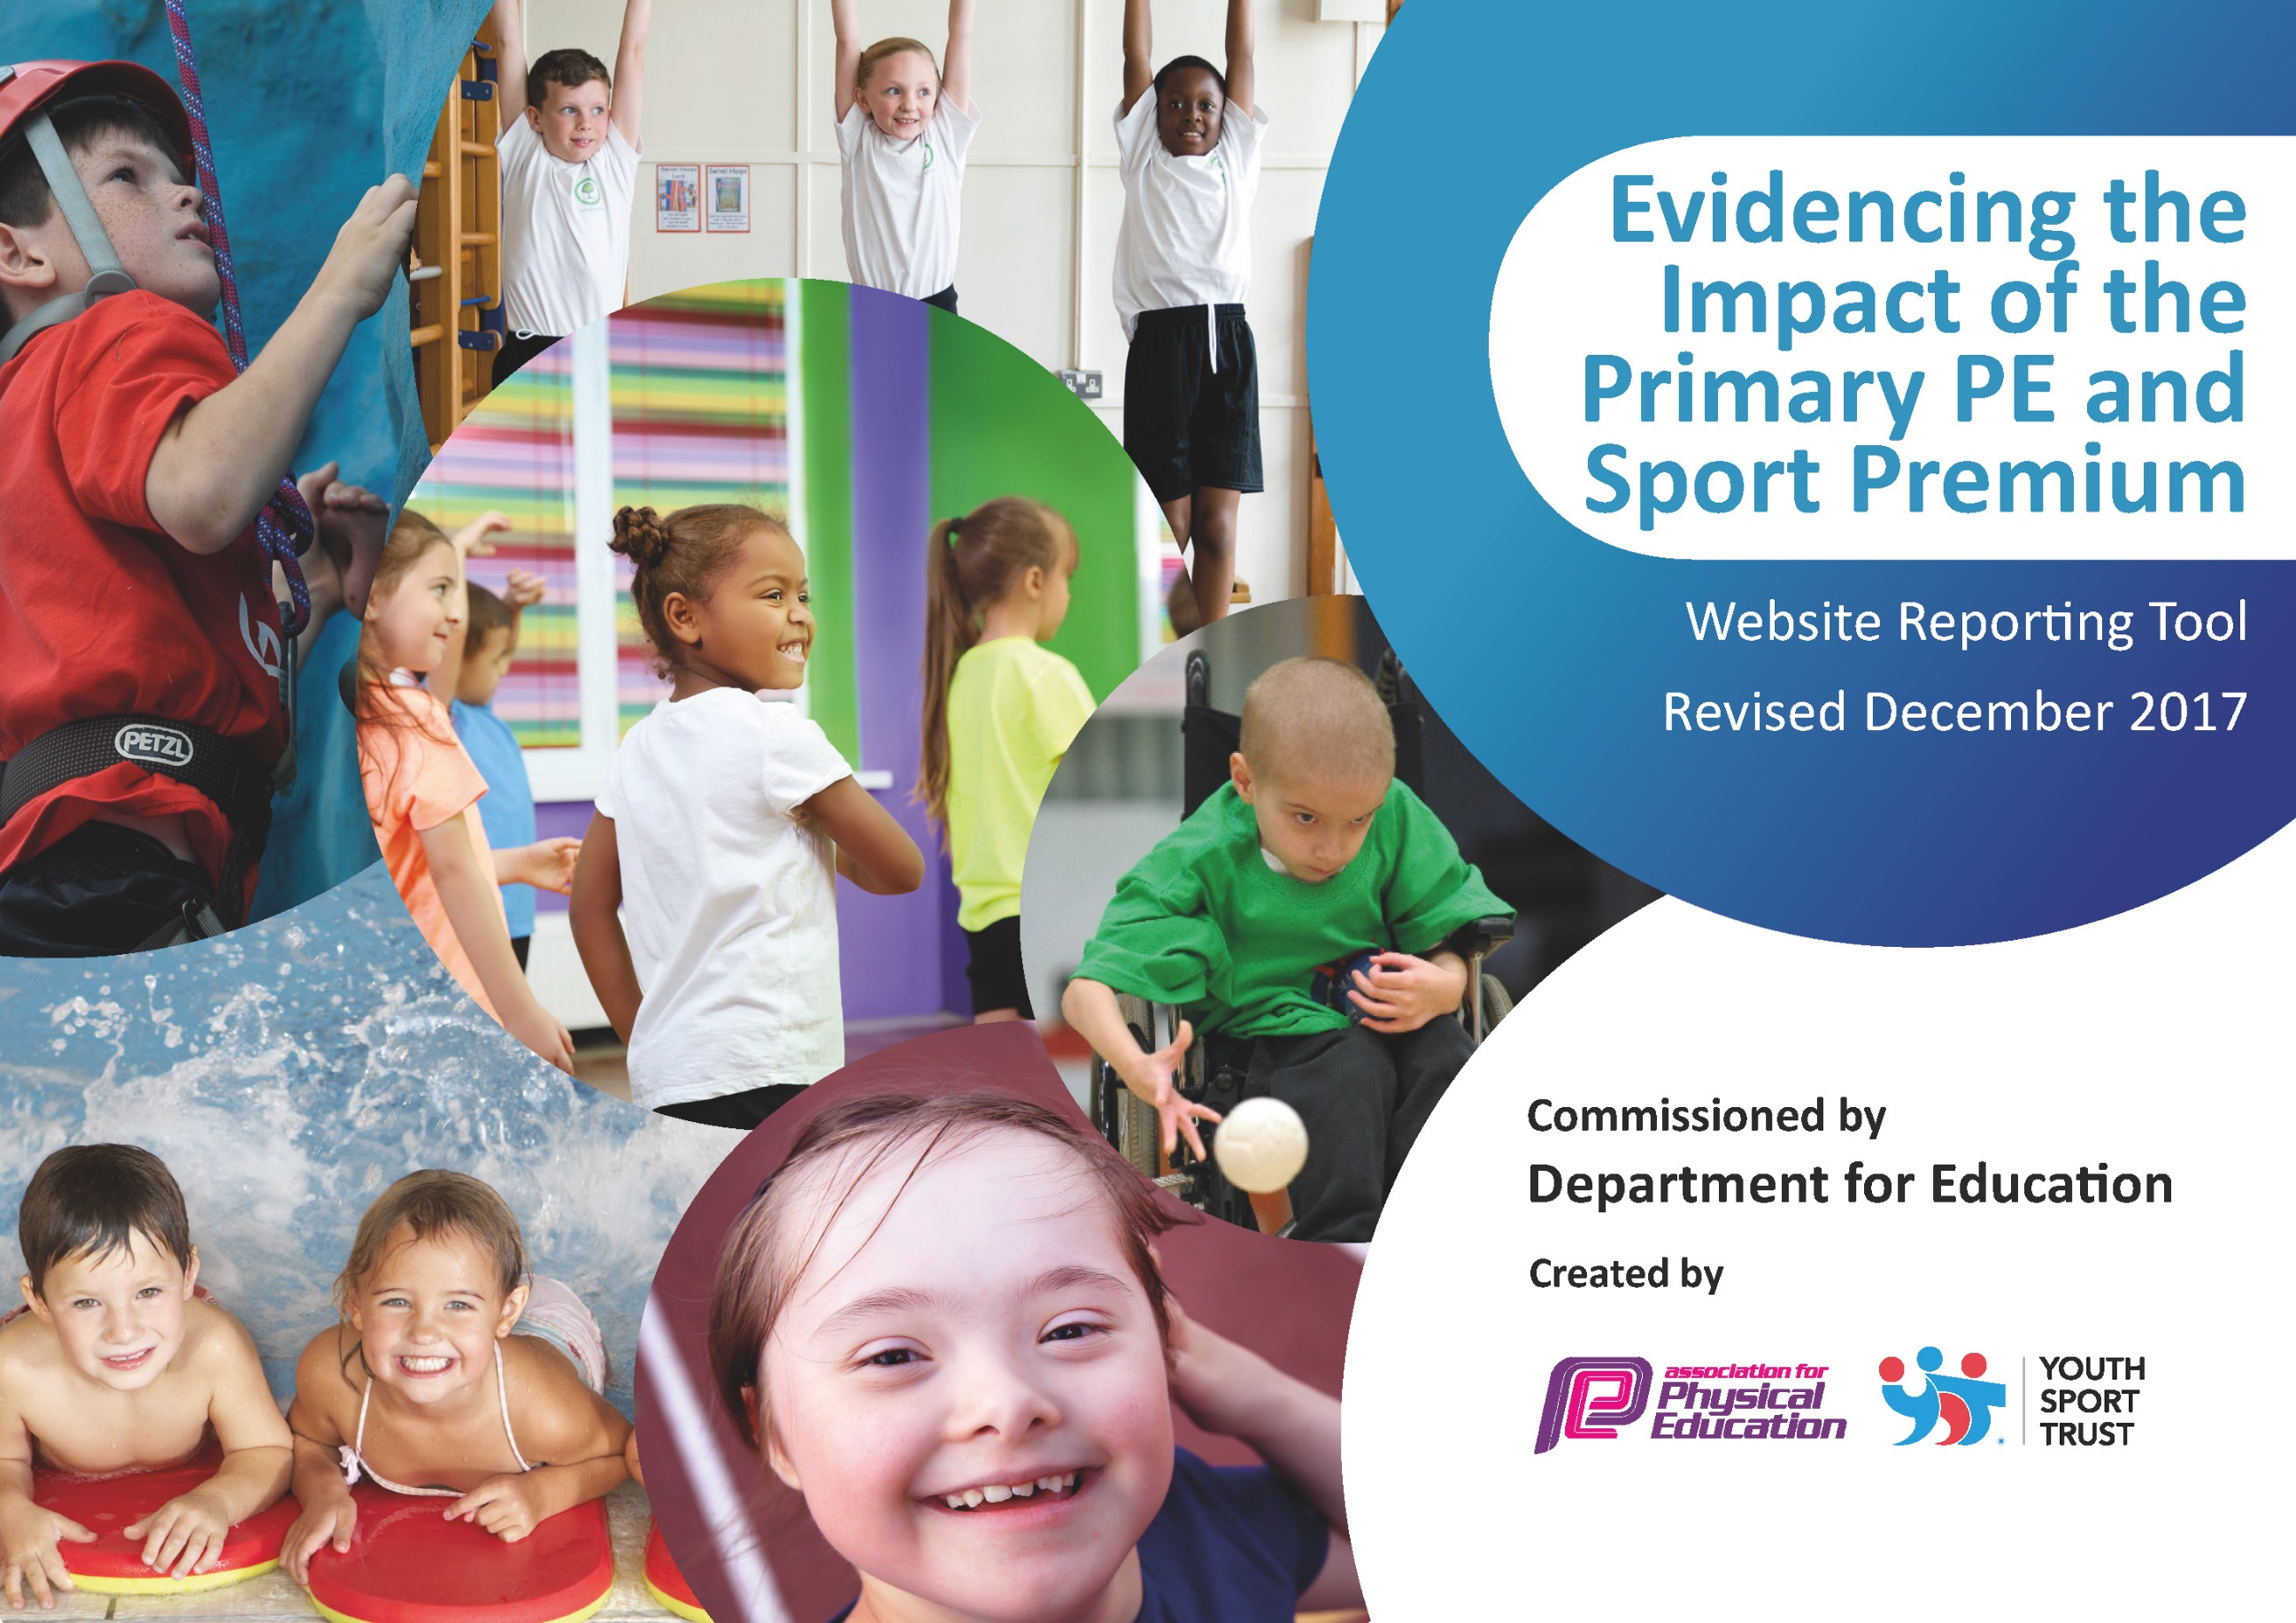

Schools must use the funding to make additional and sustainable improvements to the quality of PE and sport they offer. This means that you should use the Primary PE and Sport Premium to:

- develop or add to the PE and sport activities that your school already offers
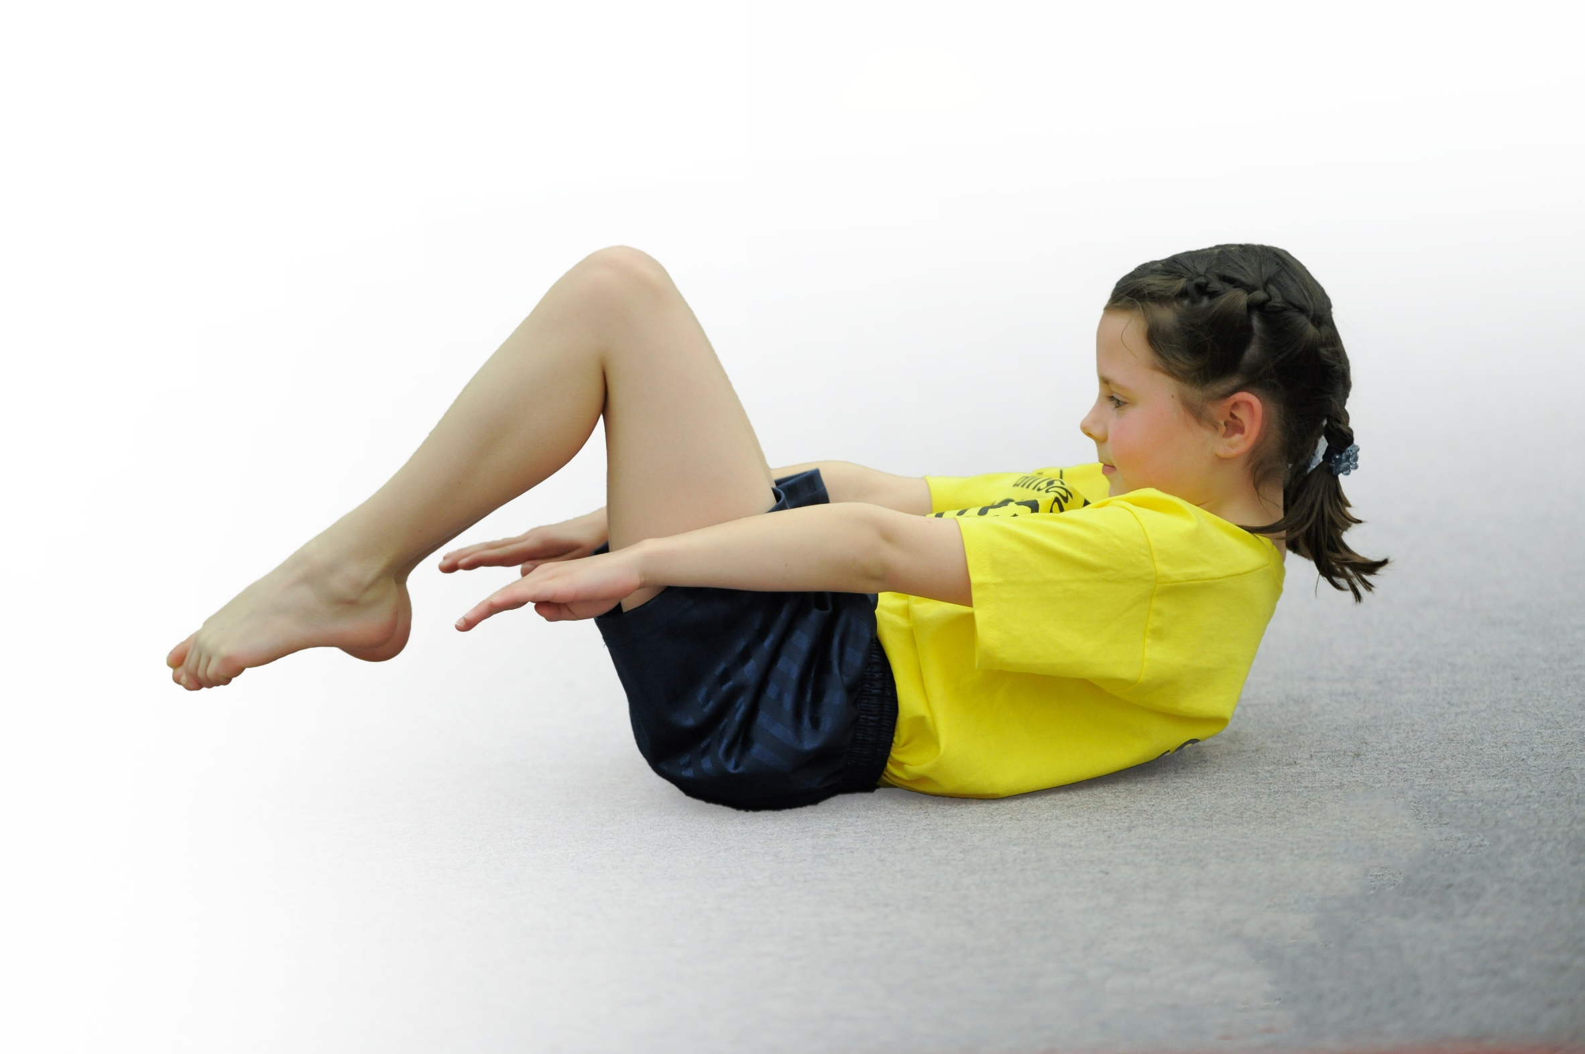
- build capacity and capability within the school to ensure that improvements made now will benefit pupils joining the school in future years

Please visit gov.uk for the revised DfE guidance including the 5 key indicators across which schools should demonstrate an improvement. This document will help you to review your provision and to report your spend. DfE encourages schools to use this template as an effective way of meeting the reporting requirements of the Primary PE and Sport Premium.

We recommend you start by reflecting on the impact of current provision and reviewing the previous spend.
Under the Ofsted Schools Inspection Framework, inspectors will assess how effectively leaders use
the Primary PE and Sport Premium and measure its impact on outcomes for pupils, and how effectively governors hold them to account
for this.

Schools are required to publish details of how they spend this funding as well as on the impact it has on pupils’ PE
and sport participation and attainment.
We recommend regularly updating the table and
publishing it on your website as evidence
of your ongoing review into how you are using the money
to secure maximum, sustainable impact. To see an example of how to complete the table please click HERE.

Support for review and reflection - considering the 5 key indicators from DfE, what development needs are a priority for your setting and your students now and why? Use the space below to reflect on previous spend, identify current need and priorities for the future.

Key achievements to date: | Areas for further improvement and baseline evidence of need:
- More sporting activities and clubs were offered to all kay stages.  - A wider range of competitions were entered.  - Change for life club relaunched and very successful with all children going on to represent school within festivals and competition. The club also won an award.  - Staff received CPD were required and all staff gained CPD in ‘daily mile’.  - The daily mile track was installed and launched with all children partaking in the mile a day. | - PE Curriculum map to assist teaching staff and show progression of skills through key stages.  - More active equipment to be installed onto the playground to encourage children to become active through breaktimes.  - CPD were required  - 30 active minutes.  - Assessment of P.E

Meeting national curriculum requirements for swimming and water safety | Please complete all of the below*:
What percentage of your current Year 6 cohort swim competently, confidently and proficiently over a distance of at least 25 metres? | 94%
What percentage of your current Year 6 cohort use a range of strokes effectively [for example, front crawl, backstroke and breaststroke]? | 94%
What percentage of your current Year 6 cohort perform safe self-rescue in different water-based situations? | 92%
Schools can choose to use the Primary PE and Sport Premium to provide additional provision for swimming but this must be for activity over and above the national curriculum requirements. Have you used it in this why? | Yes/No
*Schools may wish to provide this information in April, just before the publication deadline.

Action Plan and Budget Tracking
Capture your intended annual spend against the 5 key indicators. Clarify the success criteria and evidence of impact that you intend to measure to evaluate for students today and for the future.

Academic Year: 2017/18 | Total fund allocated: £ | Date Updated:
Key indicator 1: The engagement of all pupils in regular physical activity – Chief Medical Officer guidelines recommend that primary school children undertake at least 30 minutes of physical activity a day in school |  |  |  | Percentage of total allocation:
 |  |  |  | %
School focus with clarity on intended impact on pupils: | Actions to achieve: | Funding allocated: | Evidence and impact: | Sustainability and suggested next steps:
To implement daily mile to allow children to undertake extra daily physical activity. | Installation of the daily mile track and CPD for all staff. | £10,000 lottery grant.  £17,000 | Track installed, Staff all took part in CPD during inset day.  All children accessing track daily. | To build on this, utilizing the track for other active minutes.
Key indicator 2: The profile of PE and sport being raised across the school as a tool for whole school improvement |  |  |  | Percentage of total allocation:
 |  |  |  | %
School focus with clarity on intended impact on pupils: | Actions to achieve: | Funding allocated: | Evidence and impact: | Sustainability and suggested next steps:
To appoint sports ambassadors and train up year 5 playground leaders to encourage children to become more active and enjoy P.E and sport. | Sports ambassador appointed and trained. Year 5 trained up as PALS. |  | Sports ambassadors sat on the school council and listened to the needs and wants of the children within our school. This then was put into practice allowing different sports clubs and P.E. | To continue to use sports ambassadors and look at appointing health champions too to focus on the health and wellbeing of children.

Key indicator 3: Increased confidence, knowledge and skills of all staff in teaching PE and sport |  |  |  | Percentage of total allocation:
 |  |  |  | %
School focus with clarity on intended  impact on pupils: | Actions to achieve: | Funding  allocated: | Evidence and impact: | Sustainability and suggested  next steps:
CPD offered where needed  School P.E kit sourced and bought. | Staff sent on courses to increase confidence or offered CPD within school.  All staff given CPD on daily mile.  All staff given P.E uniform to encourage and set example to children. | £1,375.00  £1,293.00 | CPD for staff increased confidence.  PRO Direct worked with teachers offering CPD.  Uniform for P.E bought setting example and feeling of inclusion. | Continue CPD.  Develop P.E curriculum map.
Key indicator 4: Broader experience of a range of sports and activities offered to all pupils |  |  |  | Percentage of total allocation:
 |  |  |  | %
School focus with clarity on intended  impact on pupils: | Actions to achieve: | Funding  allocated: | Evidence and impact: | Sustainability and suggested  next steps:
Additional achievements:  Change for life club relaunched to target less active children. | Relaunch club  Identify children from previous years data. | £454.34 for equiptment and new scheme to follow.  £660 for staff | The club was relaunched with new name ‘Healthy aces’.  All children attended and went on to represent school within festival or competition.  The club won an awards for ‘best club’ at the primary school awards. | To continue to run the club next year, selecting children from this years data.
Key indicator 5: Increased participation in competitive sport |  |  |  | Percentage of total allocation:
 |  |  |  | %
School focus with clarity on intended  impact on pupils: | Actions to achieve: | Funding  allocated: | Evidence and impact: | Sustainability and suggested  next steps:
Enter more competitions including festivals for inclusion. | More festivals and competitions entered. | £175.00 | Children from both key stages entered Inclusion festivals.  More able students from both key stages took part in the quad kids completion. | Continue to increase participation of all students throughout the school including inclusion festivals.

