HOT SEATING DAVID from the Old Testament
Seb: Were you brave?
“Sort of because he was a very tall man against just me, a small man. It is hard to be brave.”
Max: Did you want to do it or were your forced?
“No one else volunteered. I had to do it for my people.”
Simon: How many wolves have you scared off? Did this give you certain skills?
“About 12 so far, it takes a lot of practise. Yes I’m sure facing wolves and bears helped me face this enemy of Israel.”
Kerem: How old are you?
“I’m 16. I am brave for my age but bravery is not about how old you are, it is always in your heart.”

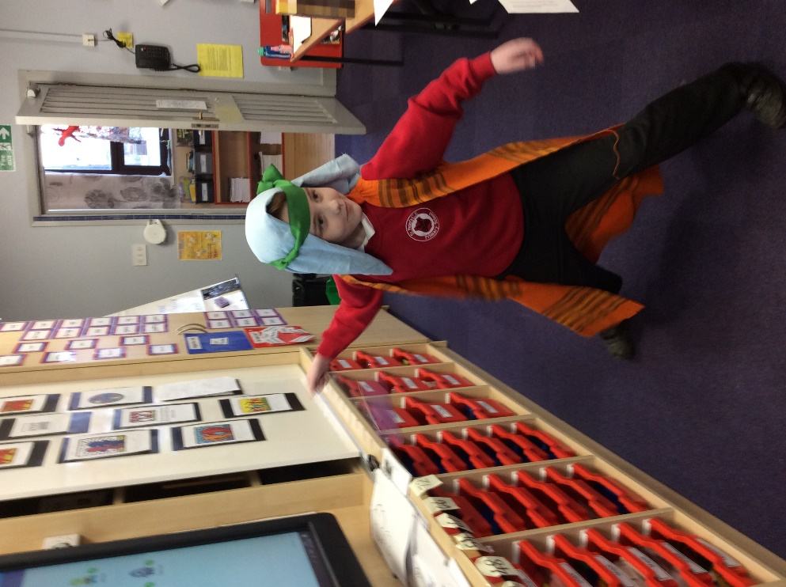
Maddison: Were you shocked when you killed Goliath?
“Yes, I couldn’t believe it only took one stone. But I have good aim.”
Kerem: How did you feel when it was all over?
“Guilty, but my people needed me to do it.”
Jorga: How did you celebrate?
“Everyone said well done to me and lifted me high on their shoulders.”
Evie: Is your relationship with your brothers strong?
“Sometimes but they did leave me all alone on the hillside protecting my sheep.”
Evie: Were you happy becoming king?
“Yes because I could bring peace and be a good leader. To be honest and help others is the important thing. I just want to bring peace to the world!”

