HOT SEATING DAVID from the Old Testament
Amelia: Do you like being a shepherd?
“I like the sunrise and protecting my sheep, it gives me the time to be alone and to think.”
Willow: Would you risk your life for your village?
“Yes because people are more important than me.”
Madeleine: Were you angry when the Philistines laughed at you?
“At first yes because I believe you should treat others how you would want to be treated.”
Nico: Do you think you could have beaten goliath without God?
“No, I don’t think I could, he encourages me and gives me strength on the inside.”

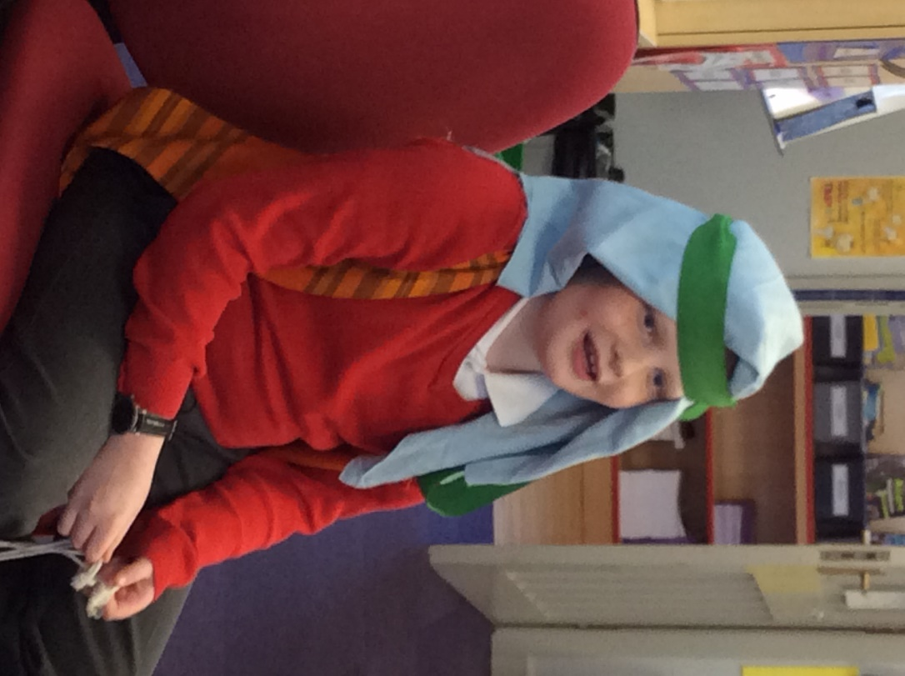
Olivia: How did you feel when he was dead?
“My first feeling was relief. Then I felt brilliant because everyone was cheering. But then I felt guilty, I had killed someone, however, I had saved my people.”
Logan: Were the Philistine Army rude?
“Extremely, they are so rude! They wanted to make our people into slaves.”

Sam: How did you kill Goliath with just one stone?
“After the prophet came, he told me I could do it with a stone, God’s stone.”
Max: Who did you really think would win?
“I believed in God and if you believe in god you can do anything.”

