
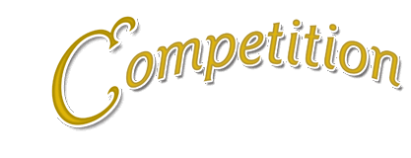
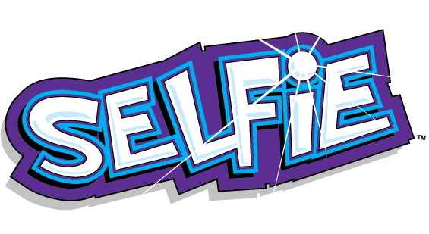

For a chance to win science goodies
Just post a selfie of yourself enjoying science outside of school.
Your selfies could include a visit or taking part in a science activity at home. Be as creative as you like and captions can be included if you wish!
Only one entry per person please.

To enter all you need to do is email your selfie with your name and class to
Mrs Mews by 09.05.16
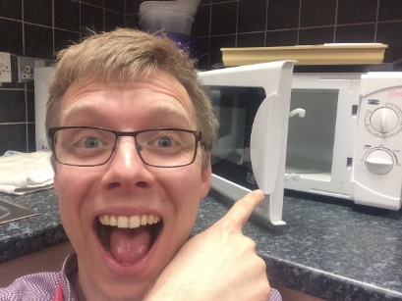
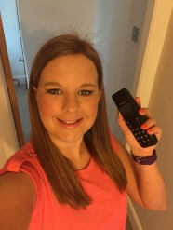
s.mews@stpeters.lancs.sch.uk


